A new stereoselective synthesis of (-)-Echinosporin

J. T. Flasz, K. J. Hale
The School of Chemistry & Chemical Engineering, Queen’s University Belfast, Stranmillis Road, Belfast, BT9 5AG Northern Ireland, UK

jflasz01@qub.ac.uk

(-)-Echinosporin (1) is a structurally complex natural product with a significant antitumour profile in vivo. It also shows strong antibiotic effects against certain bacteria.¹ Herein we present our recently accomplished formal total synthesis of 1.²
Scheme 1: Retrosynthetic analysis of (-)-echinosporin
Our pathway to 1 began with the straightforward transformation of tri-O-acetyl-D-glucal into enone 9 which was then reacted with the allenylsulfone 8 in a Padwa sulfinate-mediated [3+2]-cycloaddition to form 7 as a single diastereoisomer.³ Subsequent manipulation of the cycloadduct allowed to produce the enol ester 5 using a mild and effective new protocol for ketone C-acylation. Next, enol dihydroxylation under conformational control allowed the tertiary OH of 4 to be introduced. Installation of the double bond into the five-membered ring was achieved by converting 4 into a vinyl iodide using Barton’s method of ketone hydrazination and iodination. The latter was subsequently dehalogenated to obtain 3. Next, the primary OTBS ether of 3 was manipulated into the unsaturated amide and the ethyl glycoside was selectively hydrolysed to reveal the hemiacetal 2, which constitutes a formal synthesis of 1.⁴
References
1. T. Sato,I. Kawamoto, T. Oka, R. Okachi, J. Antibiot., 1982, 35, 266.
2. J.T. Flasz, K.J. Hale, Org. Lett., manuscript in review.
3. A. Padwa, P.E. Yeske, J. Am. Chem. Soc., 1988, 110, 1617.
4. A.B. Smith, G.A. Sulikowski, K. Fujimoto, J. Am. Chem. Soc., 1989, 111, 8039.

Synthesis and Reactivity of Cyclic Sulfonamides: Synthesis of Amarylidaceae Alkaloids Mesembrane and Mesembrine

Kimberly Geoghegan and Paul Evans
Centre for Synthesis and Chemical Biology, Dublin, Belfield, Dublin 4.

Email: Kimberly.geoghegan@ucdconnect.ie

We have shown that the sulfonyl group present in cyclic sulfonamides may be efficiently excised under reductive conditions, whereby, both the N-S and C-S bonds are reduced (eg. “double reduction” 2 to 3).^{[1]} The cyclic sulfonamide starting materials for this process are conveniently accessed by a palladium mediated intramolecular Heck reaction, followed by alkene hydrogenation (eg. 1 to 2).^{[2]} This conversion may be affected in one-pot, utilising the same catalyst in two transformations.^{[3]} In relation to the Heck reaction we have uncovered an interesting regioselectivity. Namely, that unsymmetrical trisubstituted alkenes favour C-C bond formation at the most substituted carbon atom, thereby, generating a quaternary all-carbon stereogenic centre. This selectivity and the double reduction has been applied in a short synthesis of the amarylidaceae alkaloid mesembrane 4.^{[4]}

References
1. For example see: P. Evans, T. McCabe, B. Morgan and S. Reau, Org. Lett. 2005, 7, 43
2. For a review see: J. T. Link, Org. React. 2002, 60, 157.
3. K. Geoghegan, S. Kelleher and P. Evans, J. Org. Chem. 2011, 76, 2187-2194.
4. J. E. M. N. Klein, K. Geoghegan and P. Evans, Chem. Comm. 2010, 46, 937.

Synthesis and Characterisation of New Psychoactive Substances of Abuse

R. Christie¹, J. Fox¹, C. O’Donnell¹, S. McDermott² and P. Kavanagh³
1. School of Chemical and Pharmaceutical Sciences, Dublin Institute of Technology, Kevin Street, Dublin 8.
2. Forensic Science Laboratory, Garda Headquarters, Phoenix Park, Dublin 8.
3. Department of Pharmacology and Therapeutics, School of Medicine, Trinity Centre for Health Sciences, St James’s Hospital, Dublin 8.

rachel.christie@dit.ie

New psychoactive substances were available for purchase in Irish head shops in 2010 in products such as ‘Wildcat’, ‘Ivory Wave’, ‘Rush’ and ‘Whack’ to name but a few. Analysis of these products using Gas Chromatography Mass Spectrometry (GCMS) found that these products contained synthetic cathinones such as; mephedrone, MDPV, fluorotropacocaine, methyone and butylone.¹ The Irish Government introduced an amendment (Statutory Instrument S.I. 199/2010) to the Misuse of Drugs Act on May 11, 2010. Specifically, this classed mephedrone, flephedrone (2, 3 and 4 isomers), methedrone, MDPV, butylone and methylone as Schedule 1 drugs. The more comprehensive Criminal Justice (Psychoactive Substances) Act 2010 came into effect in August 2010 and resulted in the closure of almost 100 head shops nationwide however sale of these substances continues online.
The research conducted into head shops products highlighted that there were difficulties in purchasing reference standards of the many new psychoactive substances encountered. The decision was made to synthesise the 2,3-isomers of methylone, butylone and MDPV. The iso-isomers of methylone, butylone and pentylone were also subsequently synthesised. This is the first complete synthesis of these isomers and all of the isomers have been characterised by GCMS, NMR and IR spectroscopy. This work has since been published.² The reference standards were then used to confirm the presence or absence of these isomers in Irish head shop products.
Raman spectroscopy of these synthesised isomers is ongoing; specifically to determine if this technique can be used to discriminate between the isomers. Raman has shown potential advantages as an analytical technique in the characterisation of these samples, in that the technique is non-destructive. Raman and IR spectroscopy will help to further characterise these samples.

References
- C. Kelleher, R. Christie, K. Lalor, J. Fox, M. Bowden, C. O’Donnell, http://www.nacd.ie/publications/early_PsychoactiveSubstances_overview.html 2011.
- Kavanagh, P., O’Brien, J., Fox, J., O’ Donnell, C., Christie, R., Power, J.D., McDermott, S.D. Forensic Science International http://dx.doi.org/10.1016/j.forsciint.2011.08.011

Synthesis of O-Serinyl Glycolipid Derivatives of the Immunostimulent α-GalCer.

Roisin O Flaherty, Trinidad Velasco-Torrijos¹
1. Department of Chemistry, National University of Ireland Maynooth, Maynooth, Co.Kildare.

roisin.m.oflaherty@nuim.ie

We propose the synthesis of a series of L-serine based α-galactosylceramide (α-GalCer) derivatives. α-GalCer molecules are a special class of glycolipid antigens with a potent immunoregulatory effect. They are recognised by T cell receptors of natural killer T cells which are presented by the CD1d protein of antigen presenting cells. This ternary complex initiates the rapid release of pro-inflammatory T helper (T_{H}1) and anti-inflammatory T helper (T_{H}2) cytokines. However T_{H}1 and T_{H}2 cytokines can antagonise each other’s biological functions. Opposing activities were observed for α-GalCer (Fig. 1) in both murine and human models which limits its value as potential therapeutic agents.¹ Much interest lies in the synthesis of various analogues of α-GalCer to selectively induce either a T_{H}1 (tumours and antimicrobial functions) or a T_{H}2 (autoimmune diseases) response. The synthesis of an L-serine glycolipid in preference to a sphingosine derivative offers certain advantages, such as the availability of cheaper starting materials and easier synthetic methodology (only 1 stereocentre on L-serine versus three stereocentres on sphingosine) whilst maintaining a bioisosteric relationship to the sphingosine backbone. Various serine based analogues of α-GalCer were synthesised.

Figure 1: Structure of α-GalCer.

References
1. A. Banchet-Cadeddu, E. Henon, M. Dauchez, J.H. Renault, F. Monneaux and A. Haudrechy, Org. Biomol. Chem., 2011, 9, 3080–3104.

APPROACHES TOWARDS THE SYNTHESIS OF HEPARIN ANALOGUES

K. Sheerin, S. Oscarson

Centre for Synthesis and Chemical Biology, University College Dublin, Belfield, Dublin 4, Ireland

kevin.sheerin@ucd.ie, stefan.oscarson@ucd.ie

Heparin, a major class of glycosaminoglycans, plays diverse roles in a number of physiological and pathological processes.^{[1]} These include cell adhesion, embryogenesis, viral invasion and most notably the regulation of the blood coagulation cascade.^{[2]} Heparin structures contain a high degree of complexity pertaining to the variation of sulfation pattern present throughout each structure.^{[3]}
Presented here are techniques for the syntheses of various disaccharide building blocks which allow for almost any kind of sulfation pattern from a common disaccharide precursor. Using these methods various disaccharide building blocks can be synthesised easily and in relatively few steps. Research is ongoing into using these structures to build large defined Heparin-like oligosaccharides for testing in a number of biologically relevant areas.
References
[1] I. M. Bernfield, M. Grotte, P.W. Park, O. Reizes, M. L. Fitzgerlad, J. Lincecum, Annu. Rev. Biochem, 1999, 68, 729-777.
[2] Conrad, H. E. (1998) Heparin-Binding Proteins (Academic, San Diego).
[3] Capila, R. J. Linhardt, Angew. Chem. Int. Ed, 2002, 41, 390-412.

Synthesis of Iminosugar C-Glycosides via a Tandem Allylic Azide Rearrangement – Huisgen Cycloaddition

L. Moynihan, P. V. Murphy

School of Chemistry, National University of Galway, Galway, Ireland

l.moynihan1@nuigalway.ie; Paul.V.Murphy@nuigalway.ie

Iminosugars are a family of polyhydroxylated heterocycles containing an endocyclic nitrogen atom. Iminosugars such as nojirimycin (Fig 1) and its derivatives inhibit glycosidases (carbohydrate processing enzymes)¹ and have therapeutic potential for treating metabolic disorders such as diabetes, cancer, viral infections and lysosomal storage disorders. Iminosugar based peptidomimetics have been synthesised as ligands for somatostatin receptors and HIV protease². The use of iminosugars as scaffolds, compared with pyranosides, offer the possibilty of incorporating a charged hydrogen bond donor through ring protonation of the ring nitrogen atom.
Figure 1: Nojirimycin, 1-Deoxynojirimycin and α-Homonojirimycin
The Huisgen cycloaddition is the reaction of a dipolarophile (alkene) with a 1,3-dipole (azide) to give a 5-membered heterocycle (triazoline)³. The use of an allylic azide, which undergoes rearrangement at room temperature⁴, as the 1,3-dipole in the Huisgen cycloaddition is currently under investigation for the stereoselective preparation of natural products such as α-homonojirimycin (Fig 1). Progress towards this goal will be presented.

References
1. B. Winchester and G. W. J. Fleet, J. Glycobiology, 1992, 2, 199-210
2. P. V. Murphy, Eur. J. Org. Chem., 2007, 4177-4178
3. V. Nair, T. D. Suja, Tetrahedron, 2007, 63, 2247-12275
4. A. K. Feldman, B, Colasson, B. K. Sharpless and V. V. Folkin, J. Am. Chem. Soc., 2005, 127, 13444-
13445.

DESIGNING A MOLECULAR SWITCH BASED ON HYDROGEN BONDING IN ORGANOSULFUR COMPOUNDS
Carla A. Daly, Anita R. Maguire, Simon E. Lawrence.
Department of Chemistry, Analytical & Biological Chemistry Research Facility, University College Cork, Cork, Ireland.
The solid state physical properties of organic compounds are critically important to their application as pharmaceuticals. Solid pharmaceuticals exist as polymorphs, solvates or amorphous forms which gives rise to measureable differences in physical properties and processing. The particular form determines the physicochemical properties of the drug such as its hygroscopicity, bioavailability, solubility, stability and dissolution rate.¹ Drugs crystallizing in more than one polymorphic form e.g. estradiol, ritonavir, carbamazepine have resulted in problematic quality release and stability testing of the finished dosage form.²
Advances in crystal engineering and supramolecular chemistry has led us to consider new perspectives of the various solid state forms that molecules may adopt in terms of molecular assemblies.³ Control of the physical properties demands an understanding of the nature of interactions between molecules in the solid state at a fundamental level.
This research focuses specifically on organosulfur functional groups (sulfides, sulfoxides and sulfones), with the aim to develop an understanding of how the molecular structure of the compounds impact upon the solid state crystalline structure and, in particular, to probe the relative importance of different inter/intramolecular non-covalent interactions. Our interest in exploring these interactions prompted us to investigate their use as switching entities. Molecular systems that can be induced to transform from one state to another by a certain stimuli are valued synthetic targets due to their wide range of applications.⁴ Initial work began by investigating weak hydrogen bond patterns between terminal alkynes and sulfur functional groups.⁵ More recently the research has evolved to include stronger hydrogen bonding interactions incorporating amides.

References
1 Huang, L. F.; Tong, W. Q.; Advanced Drug Delivery Reviews, 2004, 56, 321–334.
2. Snider, D. A.; Advanced Drug Delivery Reviews, 2004, 56, 391–395.
3. Rodrıguez-Spong, B.; Advanced Drug Delivery Reviews, 2004, 56, 241–27.
4. Jones, I. M.; Hamilton, A. D.; Org. Lett, 2010, 12, 3651-3653.
5. Lehane, N. K.; Moynihan, E. J. A.; Brondel, N.; Lawrence, S. E.; Maguire, A. R.; CrystEngComm, 2007, 9,1041-1050.

Synthesis of Double-Armed Calixarene Compounds for Metal Ion Sensing

Sarah Maher, Mary Deasy, Adrienne Fleming
Institute of Technology Tallaght (ITT Dublin), Tallaght, Dublin 24.

sarah.maher@ittdublin.ie

The detection of small organic molecules and metal ions plays a pivotal role in medical and environmental sciences. Technological platforms that provide sensors of high sensitivity, selectivity and stability are therefore in high demand. Calixarenes have long been recognised for their metal binding abilities and their use in chemical sensors¹. In this project a number of calixarene derivatives with triazole and bridged triazole moieties were synthesised. 1,2,4-Triazoles units were chosen as they are known to exhibit complexation with metals such as iron² and silver³. Other N-containing calixarene derivatives were also developed employing Schiff-Base chemistry to effect attachment of the nitrogen containing functional groups to the calixarene scaffold.
Binding studies have been performed using UV-VIS and NMR. The extraction capabilites of these new hosts were assessed using Pedersen’s picrate extraction technique. Calixarenes can be fabricated into CdS monolayers and preliminary results from that work indicate that they are excellent Langmuir film-forming materials.⁴ Selected hosts are currently being evaluated for their use in nanomaterials for environmental analysis, for the detection of Fe(II), Fe(III) and Pb(II) in particular. The proposed technology seeks to improve on existing methods of metal detection in waste water systems.

References
1. Y. de Gaetano, I. Clarot, J.B. Regnouf-de-Vains, Tetrahedron Letters, 2009, 50, 5793 - 5797
R.K. Mahajan, Ravneet. Kaut, V. Bhalla, M. Kumar, T. Hattori, S. Miyano, Sensors and
Actuators B, 2008, 130, 290 - 294.
2. F.Aouad, A.Florence, Y.Zhang, F.Collins, C.Henry, R.J. Ward, R.R. Crichton, Inorganica
Chimica Acta, 2002, 339, 470 - 480.
3. M. Ghassemzadeh, L. Fallahnedjad, M.M. Heravi, B. Neumuller, Polyhedron, 2008, 27,
1655 - 1664.
4. F.L. Supian, T.H. Richardson, M. Deasy, F. Kelleher,J.P. Ward, V. McKee, Sains Malaysiana, 2010, 39, (3), pp 243-433; F.L. Supian, T.H. Richardson, M. Deasy, F. Kelleher, J.P. Ward, V. McKee, Langmuir, 2010, 26 (13), pp 10906–10912.


Photochemical generation of carbon-carbon bonds using supported photomediators

M.T. Lohan¹ and N.W.A. Geraghty
School of Chemistry, NUI Galway
m.lohan1@nuigalway.ie
The generation of carbon radicals for the formation of carbon-carbon bonds is a key step in synthetic organic chemistry. Standard procedures employ radical initiators, tin compounds or peroxides. All of these methods are environmentally unfriendly because of the toxic nature of the reagents or they present safety issues. An alternative approach involves the use of a photomediator such as benzophenone to produce a nucleophilic carbon radical through hydrogen abstraction which can then attack alkenes and alkynes bearing an electron withdrawing group. This functionalises the hydrogen donor and forms a new carbon-carbon bond¹ (Scheme 1).
Scheme 1: Photochemical reaction of cyclopentanol and DMAD

The generation of carbon radicals directly from unactivated systems such as cycloalkanes, ethers and dioxolanes adds to the synthetic usefulness of the process. Reactions have also been successful with cyclic and acyclic secondary alcohols. Although a useful method, the use of a photomediator such as benzophenone has its drawbacks. Column chromatography, for example, is required to remove the photomediator which is unattractive synthetically. To overcome these deficiencies and enhance the synthetic importance of these reactions further, a series of supported photomediators have been developed. By attaching benzophenone to a solid support, silica, the need for column chromatography is eliminated as simple filtration allows the product to be isolated and allows the photomediator to be recycled. The synthesis of a variety of silica supported photomediators and their carbon-carbon bond forming reactions as well as preliminary results for molecular modelling studies of the photomediators will be discussed.
Reference
- N. W. A. Geraghty and E. M. Hernon, Tetrahedron Lett., 2009, 50, 570-573.

Novel Reactivities of the Uranyl Moiety.

A. Walshe and R. J. Baker
School of Chemistry, Trinity College Dublin, Dublin 2, Ireland

awalshe@tcd.ie

Catalysis using the actinides has been mainly limited to C-C and C-X bond forming reactions with Cp*₂AnMe₂ complexes (An = Th, U).¹ The perceived lack of reactivity with oxygen containing monomers is due to the high oxophilicity of the hard uranyl centre ([UO₂]²⁺); simple coordination may be expected. Recent results on U(IV) have started to dispel this myth.² Here we report the first example of a uranyl complex acting as a ring-opening polymerisation catalyst.³
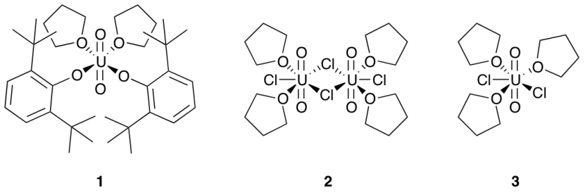
We have examined phenoxide complex 1⁴ and uranyl chloride (2,3) as potent catalysts for ring opening polymerisation of epoxides and cyclic lactones. The phenoxide complex demonstrated unprecedented activity yielding polymers with low polydispersities.³

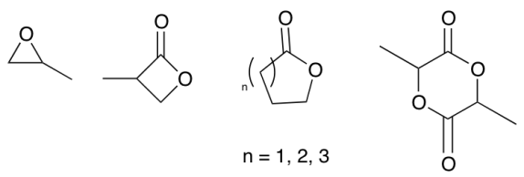
A range of monomers has been examined in an attempt to understand the electronic processes necessary for polymerisation to occur (Fig. 1). Utilising a range of NMR and emission spectroscopies we have proposed a mechanism for this system that has been validated by extensive computational investigations.
Figure 1: Monomers examined in polymerisation reactions
References
1. A. R. Fox, S. C. Bart, K. Meyer and C. C. Cummins, Nature, 2008, 455, 341-349.
2. E. Barnea, D. Moradove, J.-C. Berthet, M. Ephritikhine and M. S. Eisen, Organomet., 2006, 25, 320-322.
3. R. J. Baker and A. Walshe, Chem. Commun., 2012, 48, 985-987.
4. M. P. Wilkerson, C. J. Burns, D. E. Morris, R. T. Paine and B. L. Scott, Inorg. Chem., 2002, 41, 3110-3120.

Luminescent Dinuclear Ruthenium(II) and Rhenium(I) Complexes and their Application in Anion Recognition

Anna L. Blackburn and Nicholas C. Fletcher

School of Chemistry and Chemical Engineering, Queen’s University Belfast, Northern Ireland.

E-mail: ablackburn01@qub.ac.uk


The thiourea functionality has become widely employed in the supramolecular chemistry¹ due to its Y-shaped bidentate binding capabilities, and the NH hydrogen bond donor sites which have proved to be extremely accessible for the interaction with anions.² The use of metal complexes in anion binding is also well documented,³ with polypyridyl complexes of ruthenium(II) being amongst the most extensively studied due to their characteristic UV-vis transitions and luminescence emission. In recent years, rhenium(I) complexes have also found application in anion detection, we have reported a series of dinuclear rhenium(I) bipyridine tricarbonyl and ruthenium tris(bipyridine) complexes, bridged by a flexible diamide ethylene glycol chain which show a surprising hydrogen bonding interaction between a Re-CO group and an amide proton in low polarity solvents which can be used to detect oxoanions in non-protic media.⁴

Figure 1: Rhenium(I) bipyridyl complex, with anion bound

We report here ruthenium(II) and rhenium(I) bipyridine tricarbonyl complexes, of several new ligands, incorporating both bipyridine and thiourea functionalities, which demonstrate excellent quantum yield. The anion binding behaviour of these complexes have been tested with a range of tetrabutyl ammonium anions and their response monitored using UV / vis, emission, infrared and ¹H NMR spectroscopies.

References
(1) Gunnlaugsson, T.; Davis, A. P.; Hussey, G. M.; Tierney, J.; Org. Biomol. Chem., 2004, 2, 1856-
1863
(2) Gale, P. A.; Sessler, J. L.; Kral, V.; Lynch, V.; J. Am. Chem. Soc., 1996, 188, 5140-5141
(3) Keefe, M. H.; Benkstein, K. D.; Hupp, J. T., Coord. Chem. Rev., 2000, 205, 201-228.
(4) Pelleteret, D.; Fletcher, N.C., Eur. J. Inorg. Chem., 2008, 3579

Uptake and Activation of Carbon Dioxide by Dinuclear Macrocyclic and Macrobicyclic Complexes

Mooneerah Heerah Booluck, ^{1,3} Grace G. Morgan,^{1,3} Helge Müller-Bunz,^{1,3} Jane Nelson,^{1,3} Jeremy Scelle^{1,3}, Avishek Paul^{2,3} and Mary Pryce^{2,3}

1 School of Chemistry and Chemical Biology, University College Dublin, Belfield, Dublin 4, Ireland.
2 School of Chemical Sciences,Dublin City University, Dublin 9, Ireland.
3 SFI Strategic Research Cluster In Solar Energy Conversion.

mooneerah.heerah-booluck@ucdconnect.ie

The chemical fixation and transformation of atmospheric CO₂ is the focus of many investigations, for the dual reasons that CO₂ is both an atmospheric pollutant and a potential substrate for storing solar energy.¹ With appropriate activation CO₂ is an attractive C₁ feedstock for the preparation of useful carbon-containing compounds and its reduction may be catalyzed by reaction with metal complexes.² Macropolycyclic ligands containing two binding subunits are able to form dinuclear cryptates by inclusion of two metal cations into the molecular cavity and may further bind substrate species held by the cation centers, yielding cascade complexes.³ This project involves preparation of dinuclear polyamino cryptates, containing pairs of copper(II), nickel(II), cobalt(II), zinc(II) or cadmium(II) ions, in wet solvents in the presence of air or CO₂, which results in spontaneous fixation of CO₂ as coordinated carbonate in a variety of
binding modes, Figure 1. The results of our attempts to react the bound carbonate with hydrogen are reported here.
ClO₄ PF₆⁻ BPh₄⁻
Figure 1. Different binding modes of carbonate in [Ni₂L(CO₃)]²⁺ crypt.

References
[1] R. Eisenberg, D. G. Nocera, Inorg. Chem., 2005, 44, 6799-6801.
[2] a) D. A. Palmer, R. van Eldik, Chem. Rev., 1983, 83, 651-731; b) D. H. Gibson, Chem. Rev., 1996,
96, 2063-2095.
[3] J. M. Lehn, S. H. Pine, E. I. Watanabe, A. K. Willard, J. Am. Chem. Soc., 1977, 99, 6766-6768.

Exploiting New Molecular Targets Beyond DNA for the Development of Novel Cancer Metallochemotherapeutics.

Z. Ude, J. Parker, T. Ryan, D. Griffith and C.J. Marmion

Centre for Synthesis & Chemical Biology, Department of Pharmaceutical and Medicinal Chemistry, Royal College of Surgeons in Ireland, Dublin 2.

zigaude@rcsi.ie

Despite the enormous success of platinum drugs as anti-cancer chemotherapeutics, their widespread application and efficacy is hindered by toxic side effects and intrinsic or acquired drug resistance. The cytotoxicity of platinum drugs is attributed to their ability to bind DNA nucleobases and induce apoptosis. The search for new molecular targets beyond DNA which may present unique opportunities for therapeutic exploitation is the subject of intense investigation. Histone deacetylases (HDACs), a class of enzymes that play a key role in maintaining chromatin structure and thus function, are one such molecular target receiving considerable attention of late.
The Marmion Group have designed and developed novel platinum drug candidates with dual DNA binding and HDAC inhibitory activity as shown in figure 1.^{1,2} Building on this work, we have been developing novel ligands to complex to platinum with a view to generating a library of complexes and ultimately conducting a quantitative structure activity relationship study. The rationale behind the development of these platinum-HDAC inhibitor conjugates and the synthesis of some novel ligands to be complexed to platinum will be described.

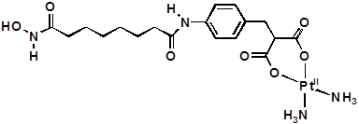

Figure 1: Bifunctional Pt^{II} anti-cancer candidate cis-[Pt^{II}(NH₃)₂(malSAHA_{H−2})].

References
- D. Griffith, J.P. Parker and C.J. Marmion, Anti-Cancer Agents Med. Chem., 2010, 10, 354-370.
- D. Griffith, M.P. Morgan, C.J. Marmion, Chem. Comm., 2009, 44, 6735-6737.

Self-assembly of calix[4]arene amine derivatives.
Laura O’Toole, John McGinley.
National University of Ireland Maynooth, Co. Kildare
laura.otoole@nuim.ie
Calixarenes are an interesting class of macrocyclic molecules that can be easily adapted to bind cationic, anionic and neutral species.¹ It is well known that molecules in solution are able to combine to form larger architectures containing two or more molecules held together by weak forces.² The most common of these include hydrogen bonding and coordination to a metal ion. The topic of this presentation is based on the dimerization of upper and lower rim substituted calix[4]arenes ‘’Fig. 1’’.
Figure 1: General calix[4]arene structure.
As part of our research, we have previously reported the design of calix[4]arene derivatives as potential ligands for energy transfer studies.^{3,} In extending this theme, we targeted the attachment of functional groups to both the upper and lower rims of our calix[4]arene scaffolds directly, without using the nitration route we had previously published.⁴ Investigations into the binding potential of various metals with these compounds was also examined.
References
1. B. S. Creaven, D.F Donlon and J. McGinley, Coord. Chem.Rev., 2009, 253, 893-962.
2. V. Rudzevich, Y. Rudzevich and V. Böhmer, Synlett., 2009, 1887-1904
3. A. D. Bond, B. S. Creaven, D. F. Donlon, T. L. Gernon, J. McGinley and H. Toftlund, Eur. J. Inorg.
Chem., 2007, 749-756.
4. B. S. Creaven, T. L. Gernon, J. McGinley, A.-M. Moore and H. Toftlund, Tetrahedron, 2006, 62,
9066-9071.

Novel Phosphorescent Chromophores for peptide labeling.

L. Blackmore ^{1,2}, C. Dolan¹, M. Moriarty¹, R.J. Forster¹, J. Prehn³, T.E. Keyes¹ and M. Devocelle²

1. School of Chemical Sciences, Dublin City University, Dublin 9, Ireland
2. Pharmaceutical and Medicinal Chemistry, Royal College of Surgeons in Ireland , Dublin 2, Ireland
3. Department of Physiology and Medical Physics, Royal College of Surgeons in Ireland, Dublin 2, Ireland

lblackmore@rcsi.ie

Luminescent dye molecules may be used as molecular probes for cellular imaging. They can be conjugated to biologically active molecules such as peptides, for sub-cellular localisation studies, to elucidate the biogical function of this peptide and its parent protein. Ruthenium polypyridyl complexes have unique photophysical characteristics which make them potentially invaluable as probes for such applications. These complexes are long lived, exhibit polarized luminescence, have good photostability, red emission wavelengths, large stokes shifts and environmental (eg. oxygen) sensitivity.¹ Although, they have long been muted as potentially useful, application of ruthenium polypyridyl complexes in cell imaging has been very limited. Ruthenium complexes often have poor water solubility and ability to transport across the cell membranes. Here, the synthesis of water-soluble probe conjugates that overcome the barrier posed by cell membranes is reported. Homing and/or cell penetrating peptide sequences have been conjugated to 2 different phosphors, [Ru(bpy)₂PIC]ClO₄ and [Ru(dpp)₂PIC]ClO₄, to target their delivery to specific sub-cellular localisations. The synthetic strategy, spectral and photophysical properties of these metal-ligand peptide complexes are described. The ability of the conjugates to enter live cancer cells was also studied by confocal microscopy. The results presented indicate that the hydrophobicity and toxicity of the metal ligand determine their capacity to translocate the cell membrane.
Figure 1: Structure of [Ru(dpp)₂PIC]ClO₄ covalently attached to a peptide sequence
Reference
1. U. Neugebauer, Y. Pellegrin, M. Devocelle, R. J.Forster, W. Signac, N.Moran, T. E. Keyes,
Chem Commun (Camb) 2008, 42, 5307-9.

Identification of Azaspiracid Biotransformation Pathways
Jennifer Geraghty ^{a,b}, Barry Foleyª, Daniel O’Driscoll^{b}
ª Dublin Institute of Technology; ^{b} Marine Institute, Rinville, Co. Galway

Azaspiracids (AZAs) are regulated lipophilic marine phycotoxins that cause Azaspiracid Shellfish Poisoning (AZP). These toxins are monitored in Ireland to avoid human consumption of these toxins and avoid AZP.
At present only AZA1, AZA2 and AZA3 are regulated in Ireland because they contribute to 95% of AZAs in mussels. AZA1 and AZA2 are produced by the phytoplankton Azadinium spinosum. All other AZAs are as a result of biotransformation within the mussel tissue. According to the most recent European Food Safety Authority (EFSA) report, AZA4 and AZA5 are hypothesised to be a result of biotransformation of AZA3. AZA4 is hydroxylation of AZA3 at the C8 position and AZA5 is the hydroxylation of AZA3 at the C22 position. The same can be said for AZA6 where it is hypothesised that AZA9 is as a result of C8 position hydroxylation and AZA10 is hydroxylation at the C22 position. Until now there has been no proof as to whether this hydroxylation occurs or at what position it’s most facile. Mussels were depurated until they contained no AZAs and 2 separate groups of mussels were fed purified AZA3 and AZA6. Mussels were removed every 24 hours (ten time points for AZA3 and eight time points for AZA6), separated into 3 body compartments (hepatopancreas, gills and the remaining tissue) and extracted using a double acetone extraction with a triple ethyl acetate/water partitioning clean up. All samples were analysed by LC-MS/MS. In the case of both feeding experiments the C22 position hydroxylation seems to be the most facile with AZA3 bioconverting to AZA5 and AZA6 bioconverting to AZA10. Little or no AZA4 or AZA9 were found in any of the samples. For AZA3, at the final time point (time point 10 = 240 hours), the percentage of AZA5 is 78%. For AZA6 most of the bioconversion happens around time point 6 (144 hours) with 44% (327 ng) of total AZAs converted to AZA10 for this time point.

Design, synthesis and evaluation of α2-Adrenoceptor antagonists: towards new and improved antidepressants.

B. Kelly, I. Rozas

School of Chemistry, Biosciences Institute, Trinity College Dublin, Dublin 2, Ireland.

kellyb2@tcd.ie

Activation of the alpha 2 adrenoceptor (α2-AR) has been implicated in the fundamental stages of depression aetiology due to its effects in the prefrontal cortex (PFC) and hippocampus.¹ It has been found in increased density and hyperactive conformation in the brains of suicide victims during autopsy.² Antagonists of the α2-AR are promising candidates for antidepressants, but the lack of a crystal structure and inconsistencies in the affinity and activity of existing ligands have made them difficult to attain.
We employed an analogue-based drug design strategy to clarify the requirements for antagonism at the α2-AR. A theoretical ab-initio, and experimental NMR and crystallography structural study³ of proposed ligands (Fig. 1, left) led to important structure-activity relationships being found during pharmacological testing.
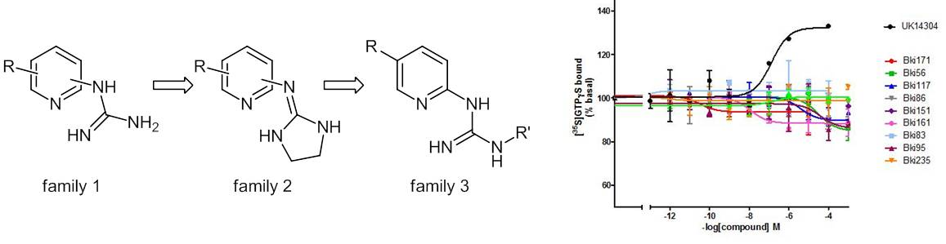
Figure 1: Families 1-3 (left) and the activity of Family 1 vs. standard agonist (right)
We exclusively obtained the desired antagonistic/inverse agonistic activity in [³⁵S]GTP-γS functional binding assays performed in PFC tissue. We also identified, and computationally verified, a number of molecular properties which resulted in increased binding affinity at the α2-AR in competitive binding experiments. These positive results and recent developments on subsequent families are presented here.
References
1. S. U. Yanpallewar, K. Fernandes, S. V. Marathe, K. C. Vadodaria, D. Jhaveri, U. Ladiwala, V. Muthig, L. Hein, P. Bartlett, V. A. Vaidya, J. Neurosci., 2010, 30, 3, 1096-1109.
2. L. F. Callado, J. J. Meana, B. Grijalba, A. Pazos, M. Sastre, J. A. Garcia-Sevilla, J. Neurochem., 1998,
70, 3, 1114–1123.
3. B. Kelly, D. H. O’ Donovan, J. O’ Brien, T. McCabe, F. Blanco, I. Rozas, J. Org. Chem., 2011, 76, 22,
9216-9227.

Artemisinin derived hybrids as potential antitumour agents
S. Gannon ¹, M. Kennedy ¹, S. L Rawe ² and J. E. J. Murphy ³

1. The Focas Research Institute, Dublin Institute of Technology, Camden Row, Dublin 8
2. The School of Chemical and Pharmaceutical Sciences, Dublin Institute of Technology, Kevin St.,
Dublin 8
3. Mitochondrial Biology and Radiation Research, Institute of Technology Sligo, Sligo

sandra.gannon@dit.ie

Artemisinin and its synthetic derivatives are established antimalarial medicines and have emerged as potent antitumour agents in recent years. These endoperoxide containing agents are prodrugs that are activated in vivo by Fe²⁺ and may exert their antitumour activity via DNA alkylation.¹ This work focuses on derivatives of artemisinin in which we have aimed to enhance antitumour activity by covalently linking them to a DNA directing group. A number of hybrids have been synthesised and the MTT assay used to determine antitumour activity.

Further research was conducted on the effect of modulation of the oxygen environment on the cytotoxic activity of the endoperoxide artesunate, a semi-synthetic derivative of artemisinin, in HeLa (a cervical cancer cell line). The cytotoxicity of artesunate was measured in biologically relevant oxygen tensions to determine if the activity of artesunate is dependent on the oxygen environment of the cells. This is of interest as hypoxia in solid tumours has been shown to reduce the activity of some cancer chemotherapies.² The ability of artesunate to function successfully under conditions of oxygen deprivation will further demonstrate the potential of these endoperoxide containing compounds as new antitumour agents.

References
1. S. Krishna, A.-C. Uhlemann, and R. K. Haynes, Drug resistance updates reviews and commentaries
in antimicrobial and anticancer chemotherapy, 2004, 7, 233-244.
2. M. Höckel and P. Vaupel, Journal of the National Cancer Institute, 2001, 93, 266-76.

Understanding the chemical behaviour of the Rh {111} metal surface for deNO_{x} applications
John J. Carey*, Jeremy P. Allen, Michael E. Bridge and Graeme W. Watson†
School of Chemistry and CRANN, Trinity College Dublin, College Green, Dublin 2, Ireland
careyj1@tcd.ie watsong@tcd.ie

NO_{x} (x=1,2) emissions are strongly oxidising gases which contribute to acid rain in the atmosphere and cause harmful smog at ground level¹. To catalytically decompose NO_{x} to N₂ and O₂ gases (deNO_{x}), a number of technologies have been developed, which utilise Rh, Pt or Pd metal catalysts embedded on oxide supports. The {111} surface of these metals are of particular interest, since they are the most thermodynamically stable surfaces. Rh is the most effective metal for deNO_{x} chemistry as it selectively produces N₂ gas and can easily break the N=O bond. By 2007, 81% of the world’s Rh supply was incorporated into deNO_{x} technologies, thus, Rh ore is becoming increasingly scarce, making it an expensive metal to use⁴. Indeed, the cost of Rh is now greater than Pd and Pt, metals that show similar deNO_{x} characteristics, albeit, not as effectively as Rh. The aim of this study is to understand the deNO_{x} chemistry of the Rh {111} surface and rationalise its superiority over the Pd and Pt {111} surfaces.
The work presented here uses density functional theory (DFT) calculations to determine the most stable adsorption modes for N, O and NO_{x} on the Rh {111} surface. The electronic interactions and charge transfer between the molecules in their most stable adsorption modes and the Rh {111} surface, is demonstrated through the use of partial (l and n quantum number decomposed) electronic density of states and Bader analysis. The energies obtained from the most stable adsorption modes build a reaction profile to present the lowest energy deNO_{x} pathway. In a similar manner, the calculated reaction profile for the Pd and Pt {111} metal surfaces was developed and is used to show that the Rh {111} surface is superior at deNO_{x} chemistry due to its stronger interaction with N atoms. The key step in the deNO_{x} pathway is the facile breaking of the N=O bond.

References
1. J. Dignon, Atmospheric Environment Part a-General Topics, 1992, 26, 1157-1163.
2. M. Shelef and G. W. Graham, Catalysis Reviews: Science and Engineering, 1994, 36, 433 - 457.
3. K. C. Taylor, Catalysis Reviews: Science and Engineering, 1993, 35, 457 - 481.
4. M. George, Commodity Report: Platinum group metals, United States Geological Survey (USGS), 2008.

Hybrid Porous Solids for Carbon Dioxide Capture.

D. Madden¹, E. Daniels¹ and T. Curtin¹

1. Materials and Surface Science Institute, Department of Chemical and Environmental Sciences
SFI-SRC in Solar Energy Conversion, University of Limerick, Ireland

david.madden@ul.ie

In conventional CO₂ capture technology, amines in aqueous solution are used for CO₂ adsorption from the gas phase with subsequent desorption at high temperature to regenerate the amine and produce an almost pure CO₂ stream. Disadvantages of this process include, large energy requirements during the amine-regenerating step, corrosion, amine degradation, foaming and amine loss due to evaporation.
As an alternative, the amines can be supported on porous solids such as Zeolites. The flue gas can then be passed through the amine rich solid which should adsorb CO₂ from the gas stream. Once the solid is fully saturated, pressure swing or temperature swing methods can be applied to the solid to initiate a CO₂ desorption cycle. This solid amine system should alleviate some of the problems associated with the conventional CO₂ capture technology.
In the adsorption process, carbamates are formed through reversible reactions of the free amine with CO₂ to form zwitterions, and a bicarbonate ion in the presence of H₂O (See Figure 1) .
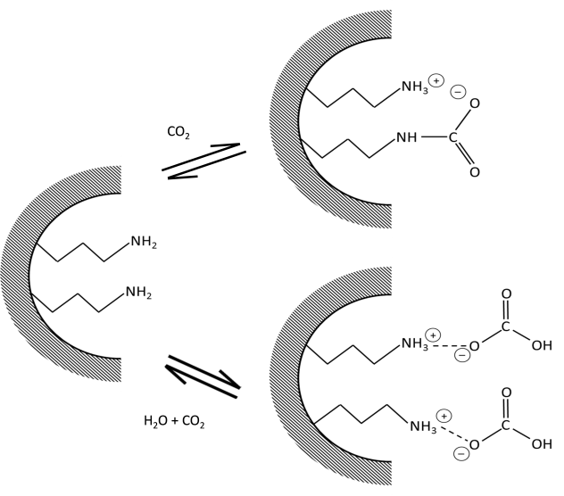
Figure 1: Carbamate Formation

Reference
[1] S. Delaney, G. Knowles, A. Chaffee, Hybrid Mesoporous Materials for Carbon Dioxide Separation,
in: ACS National Meeting Book of Abstracts, American Chemical Society, 2002.

An in-situ spatially resolved method to probe gas phase reactions through a fixed bed catalyst

J. Touitou, K. Morgan, R. Burch, C. Hardacre and A. Goguet*

CenTACat, School of Chemistry and Chemical Engineering, Queen’s University Belfast,
David Keir Building, Stranmillis Road, Belfast, BT9 5AG, UK
(*) corresponding author: a.goguet@qub.ac.uk

Development and optimization of catalysts and catalytic reactors are key steps to meet current energy challenges. Prior to the development and optimization of catalysts and catalytic reactors, the chemical reaction process must be understood. In particular, direct exploration of how a chemical reaction occurs in the presence of catalyst. Until recently the understanding of the phenomena occurring inside packed catalyst beds has been restricted¹⁻³ due to the use of probes (located at the end of the reactor) to sample the exit flow of the gases.
Reported here is a new method to study and understand the phenomena which occur within a packed bed of catalyst particles during the reaction. The spatial resolution of gas concentration profiles as a function of axial position within the catalyst bed is achieved using a mass spectrometer (see Fig. 1). The spatial resolution is provided by using a stationary drilled sampling capillary coupled to a moveable reactor. By moving the reactor periodically, the full scan of the packed catalyst bed is obtained. Additionally, this design allows visual access to the reactor via the innovative heating system. This access to the reactor will allow the coupling with a number of spectroscopic techniques in the future.

Concentration, vol%

Distance/mm

Gas profile of the CO oxidation in the catalyst bed at 250 °C; CO (▬), O₂ (▬) and CO₂ (▬).
Catalyst
Bed
Linear stage
Reactor
Hole
Capillary
MS
MS
MS
MS
MS
Gas flow
Gas flow
Gas flow
Gas flow
Gas flow
Catalyst
Bed
Linear stage
Reactor
Hole
Capillary
MS
MS
MS
MS
MS
Gas flow
Gas flow
Gas flow
Gas flow
Gas flow
Catalyst
Bed
Linear stage
Reactor
Hole
Capillary
MS
MS
MS
MS
MS
Gas flow
Gas flow
Gas flow
Gas flow
Gas flow
Distance/mm
Distance/mm
The catalyst bed is represented by the shaded area.
References
1. R. Horn, O. Korup, M. Geske, U. Zavyalova, I. Oprea, and R. Schlögl, Rev. Sci. Instrum., 2010, 81, 6.
2. O. Korup, S. Mavlyankariev, M. Geske, C. F. Goldsmith and R. Horn, Chem. Eng. Process, 2011, 50,
998.
3. J. Sa, D.L. Abreu Fernandes, F. Aiouache, A. Goguet, C. Hardacre, D. Lundie, W. Naeem, W. P.
Partridge, C. Stere, Analyst, 2010, 135, 2260.

Mediated enzyme electrochemistry: signal output and stability enhancement using tailored mediators
Peter Ó Conghaile, Brenda Egan, Domhnall Mac Aodha, Sirisha Kamireddy, Paul Kavanagh, and Dónal Leech
School of Chemistry, National University of Ireland, Galway

Mediated enzyme reactions form the basis of many applications, ranging from biosensors, through biocatalytic fuel cells, to applications in industrial electrolysis. Redox mediators can be used to help shuttle electrons between enzyme and electrode. The mediation can be tailored to redox enzymes with appropriate matching of redox potentials.
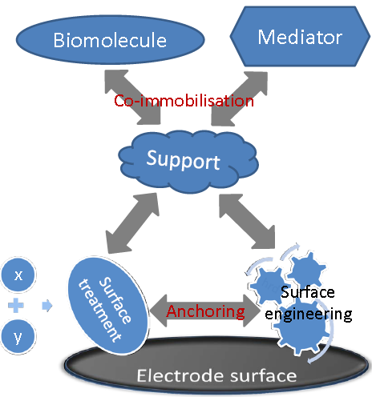
Here we present our research on tailoring surfaces through a combination of surface treatment and engineering and anchoring of polymeric supports, to provide a matrix for co-immobilisation of redox mediator and enzyme.^{1,2}

We have focused on combining a library of osmium-based functionalised redox mediator complexes with redox enzymes that can catalyse reactions of interest in biofuel cells (glucose oxidation and oxygen reduction).

Cyclic voltammetry of solutions of mediator and enzyme is used to screen for the most suitable combination providing high currents at appropriate potentials for subsequent immobilisation.

We present our most recent results using different approaches aimed at improving the stability and power output of biofuel cells and biosensors, including surface modification, electrode engineering and refinement of the immobilisation procedure.

References
- S. Boland, F. Barrière, D. Leech; Langmuir, 2008, 24, 6351-6358.
- S. Boland, P. Kavanagh, D. Leech; ECS Transactions, 2008, 13 ,(21), 77-87.

Separation of Biological Substrates by Capillary Electrophoresis with Boron Doped Diamond Electrode for Amperometric Detection
Lin Zhou¹, John H.T. Luong², Jeremy D. Glennon¹*
¹Irish Separation Science Cluster (ISSC), Department of Chemistry and Analytical, Biological Chemistry Research Facility (ABCRF), University College Cork, Ireland
²Biotechnology Research Institute, National Research Council Canada, Montreal, Quebec, Canada H4P2R2

l.zhou@umail.ucc.ie
Sensitive and selective detection of biologically important low molecular weight analytes by capillary electrophoresis with boron doped diamond electrode (BDD) for amperometric detection. BDD electrode has emerged to play an important role in improving sensitivity in electrochemical detection. Luong et al.¹ reviewed the application of BDD electrode for sensitive detection in biological analysis. Chen et al.² reviewed the application of BDD electrode as electrochemical detector in capillary electrophoresis analysis.
Electropolymerization modified BDD electrode has been used to selectively detect dopamine (DA) in urine with impressive detection limit as low as 5 nM³. The sensitivity of BDD electrode achieved for catecholamines making it suitable for using as detector for capillary electrophoresis. By coating the capillary with gold nanoparticles (AuNPs) embedded in cationic polymer poly (diallyldimethylammonium) chloride (PDDA), efficient separation and sensitive detection was achieved for analysis 3-indoxyl sulphate (IXS), vanillylmandelic acid (VMA), homovanillic acid (HVA) and tryptophan (TRP) in urine⁴.
Pseudomonas Quinolone Signal (PQS) is a quorum sensing in cell-to-cell communication in bacteria. As a bacterial culture grows, signal molecules are released into the extracellular milieu and accumulate. By controlling the electrolyte’s pH, BDD electrode can be used to selective detect PQS from its biosynthesis precursor HHQ⁵. By coupled to PDDA coated capillary, PQS, HHQ and other antibacterial 2-alkyl-4-quinolone (AHQ) compounds are separated. Different Pseudomonas mutant strains are examined by this system and the results are compatible with LC-MS results.
References
- J.H.T. Luong, K.B.Male, J.D.Glennon, Analyst,2009,134,1965.
- G.Chen, Talanta,2007,74,326.
- F.Shang, L.Zhou, K.A.Mahmoud, S. Hrapovic, Y. Liu, H.A. Moynihan, J.D.Glennon, J.H.T. Luong, Anal Chem,2009,81,4089.
- L.Zhou, J.D.Glennon, J.H.T, Luong, Anal Chem,2010,82,6895.
- L.Zhou, J.D.Glennon, F.J. Reen, F. O’Gara, C.M. McSweeney, G.P.McGlacken, Chem Comm, 2011,47,10347.

Quantitative and qualitative analysis of cell culture media using spectroscopy coupled with chemometrics.

A. Calvet¹, A. G. Ryder¹

1. Nanoscale Biophotonic Laboratory, School of Chemistry, National University of Ireland, Galway, University Road, Galway (Ireland).

amandine.calvet@gmail.com

Cell growth and product formation in biopharmaceutical productions are supported by complex cell culture media; thus media quality analysis is of critical importance. The use of fluorescence Excitation-Emission Matrix (EEM) as a potential tool for the rapid, in-situ, and routine analysis of chemically defined (CD) media was investigated. The fluorescence response of the medium was characterised using PARAFAC techniques and the matrix effects (ME) were assessed. Inner filter effect was found to be the main source of ME and was taken into account for quantitative analysis. The stability of the media was also studied using EEM and Surface Enhanced Raman Spectroscopy (SERS). The study showed that the main changes occur when the media is exposed to light as a result of photo-degradations.³ Mainly, the degradation of riboflavin and formation of a new intense fluorophore, were observed. The principal fluorophores, tryptophan and tyrosine (paper submitted to Anal Bioanal Chem) and weaker fluorophores, vitamins B2 and B6, could be predicted with errors inferior to 5% using NPLS methods.
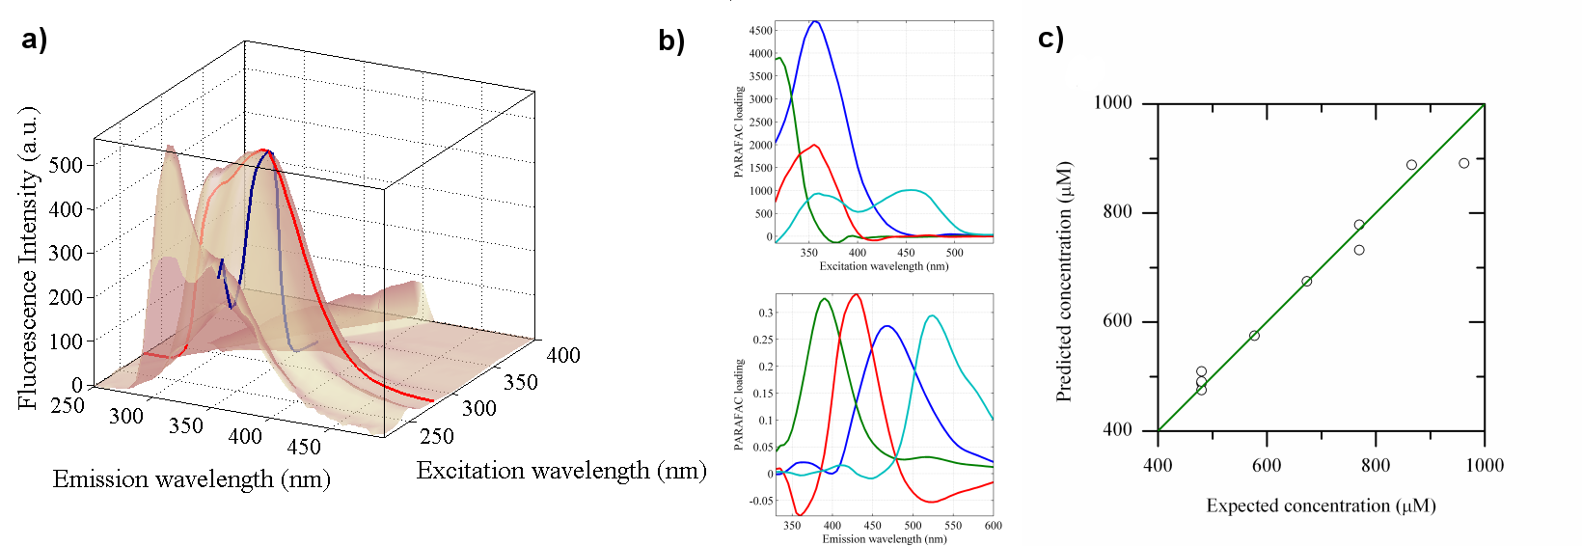
Figure 1: CD cell culture media EEM landscape (a) with results from qualitative (PARAFAC loadings, b) and quantitative analysis (predicted vs. expected concentration curve, c)
References
1. E. K. Read, J. T. Park, R. B. Shah, B. S. Riley, K. A. Brorson and A. S. Rathore, Biotechnol. Bioeng., 2010, 105, 276-284.
2. P. Ryan, B. Li, M. Shanahan, K. Leister and A. Ryder, Anal. Chem., 2010, 82, 1311-1317.
3. B. A. Kerwin and R. L. Remmele Jr, J. Pharm. Sci., 2007, 96, 1468-1479.

Controlling the Geometry and Binding Studies of New Rotameric Molecular Clips

Zenefar Yeasmin, Brian A Murray and Bernie Creaven

Department of Science, Institute of Technology Tallaght, Dublin - 24

zenefar@itnet.ie

Molecular clips are well-known artificial receptors for dihydroxyaromatics, e.g. resorcinol and other biomolecules bearing a dihydroxyaromatic unit. Two xylylene walls and two carbonyl groups, making a pre-organized cavity, are the key features which bind the substrate via two aryl-stacking & two hydrogen-bonding interactions^{[1]} (Figure 1).

 | ≡  locking phenyl | (resorcinol)
Figure 1: a molecular clip binds resorcinol via aryl stacking and H-bonding
Recently we have prepared^{[2]} new clips which exist as "rotamers" (isomers interconverted by rotation about a single bond; Figure 2). A VT-NMR study shows that the barrier for the interconversion of these rotamers, together with free energy calculations, is almost the same for any substituents at 3,3-positions of the locking phenyl. The energy barrier was found to be too high to access by VT for 2,2-disubstituted clip. The values of binding constants were found to be comparable with those presented in the literature for analogous molecular clips.^{[1][2]}
exo
endo
Figure 2: interconversion from cis (middle) to trans (left and right)

References
[1] (a) Sijbesma, R. P.; Wijmenga, S. S.; Nolte, R. J. M. J. Am. Chem. Soc. 1992, 114, 9807; (b)
Sijbesma, R. P.; Bosman, W. P.; Nolte, R. J. M. J. Org. Chem. 1991, 56, 3199; (c) Smeets, J. W. H.;
van Dalen, L.; Kaats-Richter, V. E. M.; Nolte, R. J. M. J. Org. Chem. 1990, 55, 454.
[2] Kozien, M. PhD Thesis, ITT Dublin, 2009.
Solution Mediated Polymorphic Transformation FII(6.403) to FIII(6.525) Piracetam

A. Maher, A.C. Rasmuson, C.C. Seaton, D.M. Croker, B.K. Hodnett
Solid State Pharmaceuticals Cluster, Materials and Surface Science Institute, University of Limerick
anthony.maher@ul.ie
Polymorphism in crystalline solids is defined as materials having the same chemical composition but different lattice structure orientations and/or different molecular conformations and, therefore, different physico-chemical properties. A polymorphic transformation occurs when a particular phase becomes unstable as a result of environmental conditions. Solution mediated polymorphic transformations (SMPT) can be affected by numerous parameters. The effect of these parameters on the SMPT from FII(6.403) to FIII(6.525) piracetam were studied on two scales (25 g and 130 g solution). An insight into the mechanism of the SMPT was also obtained. Figure 1 shows the SMPT monitored via in-situ ATR-FTIR of solution concentration and ex-situ XRD of the solid phase. The results indicate that nucleation and growth of FIII(6.525) are limiting in the SMPT.¹ Homogenous nucleation of FIII(6.525) was not seen under similar levels of supersaturation as the SMPT, indicating that heterogeneous nucleation of FIII(6.525) occurs. This claim was furthered by the finding that the nucleation rate was altered by the available FII(6.403) surface area.
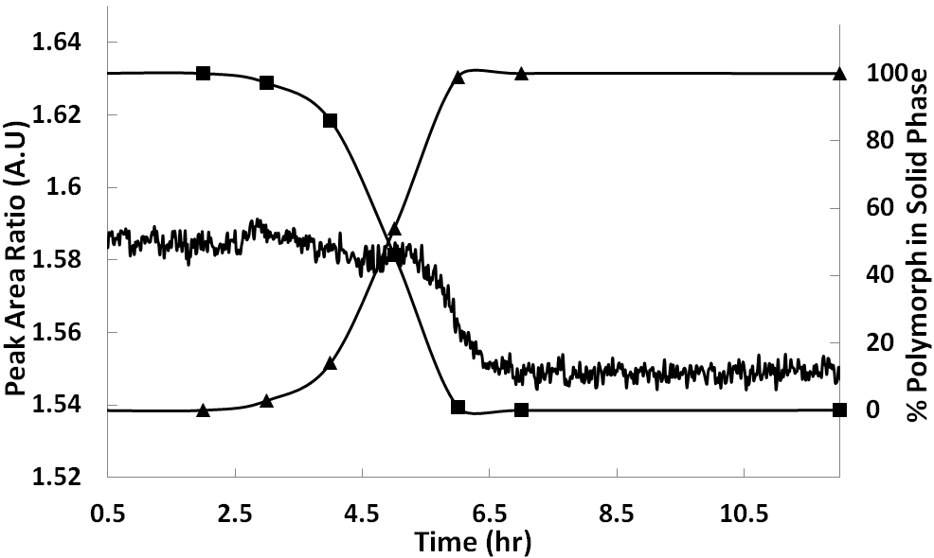
Figure 1: SMPT in ethanol at 50 ˚C. ▲, % FII(6.403); ■, % FIII(6.525); Solid line, Solution concentration.
Increasing temperature and agitation were found to increase the SMPT rate. The rate was found to be faster in solvents where piracetam has a higher solubility.² However, 2-propanol did not comply. Molecular modelling showed different solvent-solute interactions with 2-propanol compared to the other solvents which are thought to account for the surprisingly slow transformation rate in 2-propanol.³
References
- Maher, A. Rasmuson, A. C. Croker, D. M. Hodnett, B. K., Solution Mediated Polymorphic Transformation: Form II to Form III Piracetam in Ethanol, Manuscript in preparation
- Maher, A. Croker, D. Rasmuson, A. C. Hodnett, B. K., The Solubility of Form III Piracetam in a Range of Solvents, J. Chem. Eng. Data 2010, 55, 5314 – 5318
- Maher, A. Seaton, C. C. Rasmuson, A. C. Croker, D. M. Hodnett, B. K., Effect of Solvent on the Solution Mediated Polymorphic Transformation, Form II to Form III, Piracetam, Manuscript in preparation

Structural systematic studies of n × m isomer grids.

Pavle Močilac and John F. Gallagher

School of Chemical Sciences, Dublin City University, Dublin 9

john.gallagher@dcu.ie

A structural systematic study was performed on 3×3 isomer grids of benzamides and carbamates.¹⁻⁴ Four (3×3) isomer grids comprising N-(pyridyl)benzamides (Fxx⁴ and Mxx¹, see Moo dimer¹ in Fig. 1) (x = para-/meta-/ortho-) and N-(phenyl)pyridinecarboxamides (NxxF² and NxxM³) were synthesised and characterised (NmpF tetramer² in Fig. 2). All compounds were determined by single crystal X-ray diffraction. Five series of CxxR (R = CH₃, OCH₃, F, Cl, Br) carbamate isomer grids have been synthesised and characterised, with pertinent structures determined by X-ray diffraction. Ab initio modelling, conformational analysis and comparisons of experimental solid state with optimised molecular geometries have facilitated an explanation of the relationships between conformations and inter/intramolecular interactions, rationalisation of differences between the solid state and calculated structures, as well as molecular disorder and polymorphism behaviour.¹⁻⁴
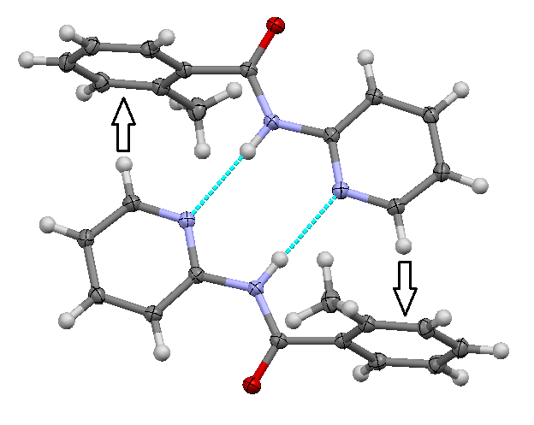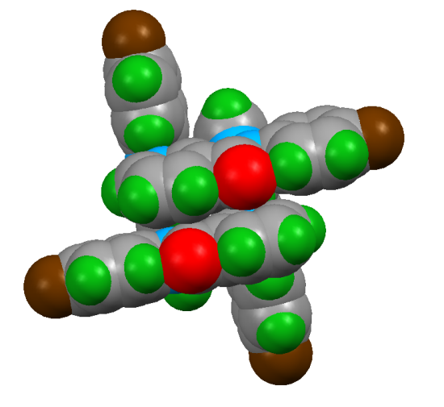
Figure 1: The Moo dimer Figure 2: The NmpF tetramer

References
1. P. Mocilac, M. Tallon, A.J. Lough and J.F. Gallagher, CrystEngComm, 2010, 12, 3080-3090.
2. P. Mocilac, A.J. Lough and J.F. Gallagher, CrystEngComm, 2011, 13, 1899-1909.
3. P. Mocilac and J.F. Gallagher, CrystEngComm, 2011, 13, 5354-5366.
4. P. Mocilac, K. Donnelly and J.F. Gallagher, Acta Crystallogr. - Struct.Sci, 2012, B68, 189-203.

Seedless Growth of Germanium Nanowires: Coalescence and Ostwald Ripening

O.Lotty¹, R. Hobbs¹, C. O’Dwyer², N. Petkov¹ and J. D. Holmes^{1, 3}

1. Materials Chemistry and Analysis Group, Department of Chemistry, University College Cork,
Ireland and the Tyndall National Institute, University College Cork, Cork, Ireland.
2. Materials & Surface Science Institute (MSSI), University of Limerick, Limerick
3. Centre for Research on Adaptive Nanostructures and Nanodevices (CRANN), Trinity College Dublin,
Dublin 2, Ireland.

j.holmes@ucc.ie

In this work we have grown seedless Ge nanowires using various mixed Ge/Si precursors. Analysis of the diameter distributions of each of these experiments revealed several trends in growth behaviour which can be directly linked to the precursor used and the temperature employed. We further propose that by analysing the statistical diameter distribution of the nanowires formed the mechanism of wire growth can be determined. The nanowires are seen to follow the homogenous nucleation pathway which is followed by coalescence and then Ostwald ripening. These three main stages (nucleation, coalescence and Ostwald ripening) are not sharply distinguished, but in fact overlap during the evolution from a supersaturated phase to a ripened nanowire in the condensed phase.¹ We combine a commonly accepted model of coalescence with a model for Ostwald ripening which takes into account this overlap and fit the collected data to this model. The wires reported here were made with a variety of metal/organic precursors which were deliberately tuned to alter the Ge:Si ratio. The germanium nanowires produced were coated with a material consisting of a layer of Si, Ge, O and C. This amorphous coating was a by-product of precursor decomposition and plays an important role in the broadening of the nanowire diameters.

Reference
1. G. Madras and B. J. McCoy, Chem. Eng. Sci. 2002, 57 (18), 3809-3818.

Size Controlled Growth of Germanium Nanorods and Nanowires by Solution Pyrolysis Directly on a Substrate

Emma Mullane,¹ Hugh Geaney¹ and Kevin M. Ryan¹

- Materials and Surface Science Institute and Department of Chemical and Environmental Sciences, University of Limerick, Limerick, Ireland

Emma.Mullane@ul.ie
Group IV semiconductor nanowires (NWs) have been incorporated into a variety of novel devices in the fields of nanoelectronics, batteries and photovoltaics.¹ The growth processes for these materials typically rely on a nanoparticle seed alloying with the semiconductor to allow growth.² While the diameter is governed by the initial seed size, precise length control remains elusive due to the catalytic nature of the process. Generating NWs or nanorods (NRs) with defined aspect ratios, inherently increases their suitability for both discrete devices and high density architectures. Here, a simple pyrolyis method is shown to allow the Ge feedstock for 1D growth to be accurately tuned, allowing the structures to be tailored from high aspect ratio nanowires (>10 μm in length) to shorter aspect nanorods (100 nm in length). The route provides a quick, straightforward method for synthesizing NWs and NRs with a high degree of dimensional control.³ Furthermore, it broadens the spectrum of attainable materials produced by simple synthesis routes directly on substrates.
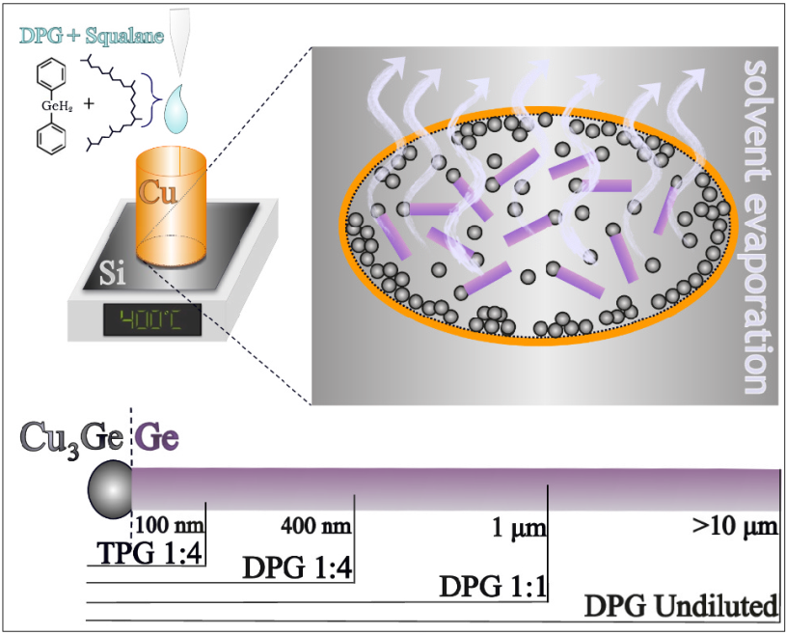
Figure 1. Schematic illustrating the growth system used

References
1. V. Schmidt, J. V. Wittemann, S. Senz and U. Gösele, Advanced Materials, 2009, 21, 2681-2702.
2. H.-Y. Tuan, D. C. Lee and B. A. Korgel, Angewandte Chemie, 2006, 118, 5308-5311.
3. E. Mullane, H. Geaney and K. M. Ryan, Chem. Commun., 2012.

Manipulating Connectivity in Random Nanowire Networks – a Route to Intelligent Materials.

Allen T. Bellew^{1,2}, Alan P. Bell^{1,2}, Jessamyn A. Fairfield^{1,2}, and John J. Boland^{1,2}

1. School of Chemistry, Trinity College Dublin, Dublin 2
2. Centre for Research on Adaptive Nanostructures and Nanodevices, Trinity College Dublin, Dublin 2

bellewa@tcd.ie

Random networks of nanowires have demonstrated uses as transparent electrodes with optical conductivities and sheet resistances matching industry requirements¹. Now we show that the connectivity across nanowire networks can be manipulated, that networks remember this manipulation, and that it is a property of all random networks. Networks of silver nanowires, coated with an insulating polymer layer, were examined using Conductive Atomic Force Microscopy, passive voltage contrast SEM and 2-probe current-voltage measurements. The dynamic evolution of network connectivity is shown to split into two separate regimes at different densities/separations. This behaviour was also witnessed in networks of transition metal oxide nanowires with resistive switching properties, where the switching element adds an additional layer of complexity to the system. Such dynamic materials may allow for self-repairing conductors, new forms of memory technology and self-learning systems.
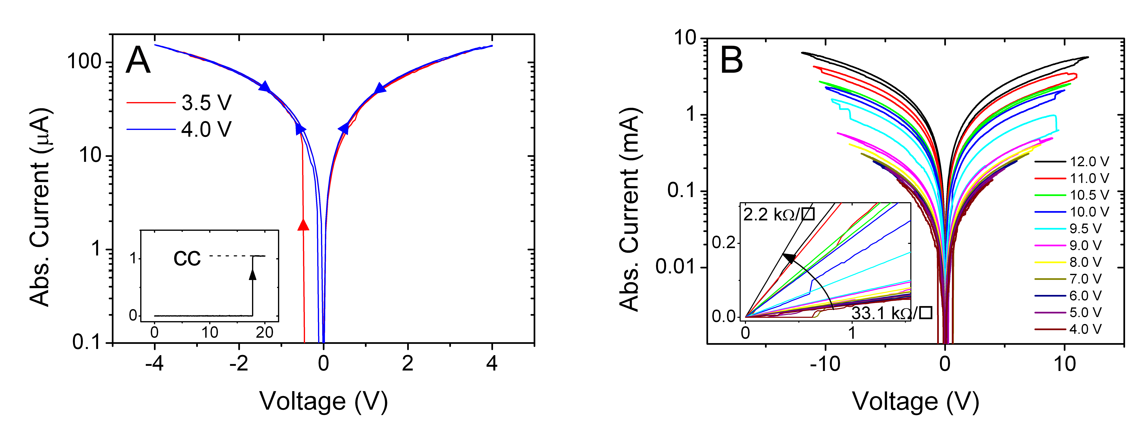
Figure 1: Connectivity evolution in nanowire networks at different length scales; (A) 40 μm, and (B) 1 mm electrode separations.

Reference
1. S. De, T. M. Higgins, P. E. Lyons, E. M. Doherty, P. N. Nirmalraj, W. J. Blau, J. J. Boland and J. N. Coleman, ACS Nano, 2009, 3, 1767-1774.

Novel template-free electrochemical growth and post-functionalization of N-substituted polypyrrole nanowires

N. B. McGuinness, C. B. Breslin and A. D. Rooney

Environmental Technologies and Biomaterials Research Group, Chemistry Department,
NUI Maynooth, Co. Kildare

niall.b.mcguinness@nuim.ie, denise.rooney@nuim.ie

The first template-free electrochemical deposition of poly[N-(2-azidoethyl)pyrrole] and poly[N-(2-cyanoethyl)pyrrole] nanowires, producing homogeneous films across the substrate have been developed.¹ Post-functionalization is performed when electroactive metal complexes are covalently incorporated into the novel morphology by employing ‘click’ methodology and finally characterized by spectroscopic analyses. Possessing desirable polymer film characteristics such as high surface area and short diffusion lengths, this facile procedure yields potentially attractive, modified electrodes for use in both chemo- and bio-sensing technologies.^{2,3}

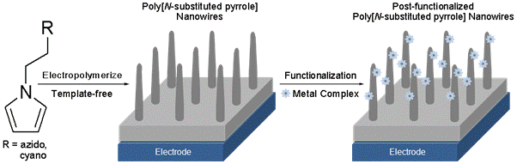
Figure 1: Growth/functionalization of nanowire films

References
- C. P. McCarthy, N. B. McGuinness, B. E. Alcock-Earley, C. B. Breslin and A. D. Rooney, Electrochem. Commun., 2012, 20, 79-82.
- G. Fabregat, E. Cordova-Mateo, E. Armelin, O. Bertran and C. Aleman, J. Phys. Chem. C, 2011, 115, 14933-14941.
- S. Bourigua, S. El Ichi, H. Korri-Youssoufi, A. Maaref, S. Dzyadevych and N. J. Renault, Biosens. Bioelectron., 2011, 28, 105-111.

Fabrication of 3D Nanodimensioned Electric Double Layer Capacitor Structures Using Block Copolymer Templates

Sozaraj Rasappa^{1,2}, Dipu Borah^{1,2,3}, Ramsankar Senthamaraikannan^{1,2},
Colm C Faulkner², Justin D Holms^{1,2,3} and Michael A Morris^{1,2,3*}

¹, Materials Section, Department of Chemistry, University College Cork, Cork, Ireland;
², CRANN, Trinity College Dublin, Dublin, Ireland;
³, Tyndall National Institute, Cork, Ireland;
⁴, Intel Ireland, Leixlip, Co. Kildare, Ireland

*Corresponding author: Email: m.morris@ucc.ie, Ph: +353 214902180; Fax: +353 214274097

The microphase separation of a symmetric diblock copolymer, consisting of polystyrene (PS) and poly(methylmethacrylate) (PMMA, (PS-b-PMMA), film at a silicon substrate was used to generate a line pattern at the surface. Selective ion etching was used to remove the PMMA component thereby forming a topographic PS pattern. The templates thus formed were used to fabricate copper nanowires by evaporation technique. Focused Ion Beam (FIB) and TEM cross-section analysis revealed the formation of 3-D copper nanostructures on the substrates. The electrochemical behaviour of the copper nanostructures was studied using a potentiostat which showed cyclical charging and discharging phenomenon. The application of these materials and methods for the fabrication of nanocapacitors is discussed.

(Keywords: Block copolymer; PS-b-PMMA; Thermal anneal; Plasma etching; Templates; 3D copper nanowires; nanocapacitors, electric double layer capacitors)

Development of metal nano-particle agglomerated polymer monoliths for capillary LC applications.

Patrick Floris*¹, Damian Connolly^{1,2} and Brett Paull ³

¹1rish Separation Science Cluster, National Centre for Sensor Research, Dublin City University, Dubin 9, Ireland.
²School of Chemical Sciences, Dublin City University, Dublin 9, Ireland
³Australian Centre for Sensor Research on Separation Science (ACROSS), School of Chemistry, University of Tasmania, Hobart, 7005, Australia

The chromatographic applications of stationary phases based on porous polymer monoliths (PPMs) have been traditionally confined to mainly large molecules such as proteins or peptides. The separation of small molecules such as inorganic ions however represents a challenge due to the limited surface area present in such monolithic materials. Previous reports have documented the preparation of monoliths for ion exchange applications either by direct co-polymerization of functional monomers or by subsequent modification of the monolithic surface with ion exchange groups, either by chemical modification or grafting techniques. With co-polymerization the relative density of charged functional groups is relatively low, however by availing of photo-grafting techniques extensive branching occurs along the surface leading ultimately to a much higher surface coverage of ion exchange groups. In order to improve the limited surface area of PPMs, recent development has been aimed at modifying the surface chemistry for the immobilisation of metal nano-particles (NP) due to the high surface to volume ratio of such materials. In this work agglomerated polymer monoliths functionalised with Au NPs have been prepared in situ for capillary ion exchange applications. A reactive monomer, glycidyl methacrylate, was photografted on the surface of a polymer monolith. The ring-opening reaction of the epoxy groups in the presence of ethylenediamine allows the formation of strong covalent bonds with the NH₂ groups which are known to have a strong affinity for Au NPs, allowing their subsequent immobilisation. FE-SEM was used to confirm the high coverage of Au NPs across the entire monolithic bed. The Au nano-agglomerated monolith was then modified with sodium-2-mercaptosulfonate leading to cation-exchange functionalities. For example, retention of Ca²⁺ was observed using CuSO₄ as eluent. Similarly, 1-octanedecanethiol was used for modification of a similarly prepared Au functionalised monolith for the preparation of a reverse phase stationary phase allowing retention of a series of hydrophobic molecules.

Synthesis and Characterisation of Charged Iron Oxide Nanoparticles and their Composite Materials for Potential Targeted Drug Delivery

Sarah P. Clarke and Dermot F. Brougham

School of Chemical Sciences, Dublin City University, Glasnevin, Dublin 9.

sarah.clarke8@mail.dcu.ie

Magnetic iron oxide nanoparticles (IONP) and their composite materials have received considerable interest due to potential bio-applications in areas such as drug delivery, magnetic resonance imaging and thermogenic treatments. IONP can be prepared via straight-forward synthetic routes, typically yielding small nanoparticles of < 20 nm, exhibiting low toxicity in-vivo which can be easily excreted from the body. Good particle crystallinity (and hence strong magnetisation) is critical for their application. In particular, particles in this size range are superparamagnetic, i.e. they do not retain any bulk magnetisation on removal of an external field, and so form stable suspensions.^{1,2} Non-hydrolytic IONP syntheses involving thermal decomposition of iron precursors at high temperatures followed by phase transfer into aqueous media are usually preferable as they permit particle size control and superior crystallinity.³ This approach also allows functionalisation of the IONP and engineering of the surface charge. These are key advantages for the design of therapeutics for Magnetic Drug Targeting (MDT).
With MDT drugs can be incorporated into the core of the composite, or adsorbed via ionic or covalent linkage onto its surface. Once transported to the site of interest, drug release can be facilitated by many methods such as bond degradation, pH cleavage, or RF irradiation producing a local temperature increase (hyperthermia). In this way MDT offers benefits over conventional non-specific delivery methods; it allows increased drug efficacy while using the lowest possible dose and, in turn, reducing the potential toxicity and side effects usually associated with increased drug concentration in vivo. This study focuses on the use of poly (alkyl-cyanoacrylate) nanoparticles (PACA) as a delivery vehicle which, when combined with magnetic iron oxide nanoparticles, form what we have termed ‘composite materials’ for potential magnetic drug targeting.
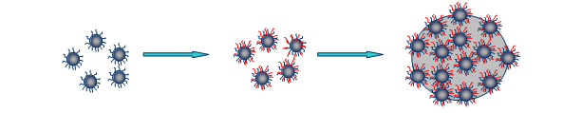
Figure. Preparation of nanoparticle-polymer composite material

References
- S. Laurent, D. Forge, M. Port, A. Roch, C. Robic, L. Vander Elst and R. N. Muller, Chem. Rev., 2008, 108, 2064–2110.
- S. Ghosh, D. Carty, S. P. Clarke, S. A. Corr, R. Tekoriute, Y. K. Gun’ko, D. F. Brougham. Physical Chemistry Chemical Physics, 2010, 12, 14009-14016
- T. Ninjbadgar, D. F. Brougham. Advanced Functional Materials, 2011, 21, 4769-4775.

(P(EO-co-glycidyl peptides) as nanomedicine candidates or polymeric carriers for targeted delivery of biopharmaceuticals.

A. O’Connor, J. N. Marsat and M. Devocelle

Centre for Synthesis and Chemical Biology, Department of Pharmaceutical & Medicinal Chemistry, Royal College of Surgeons in Ireland, 123 St. Stephen’s Green, Dublin 2
aoifemoconnor@rcsi.ie

Peptides and proteins have great potential as therapeutics and for the generation of delivery systems and biomaterials, due to their structural and functional properties, but their use in vivo is hindered by their rapid degradation, low solubility and their potential immunogenicity¹. Many polymer-peptide conjugates have been developed to overcome these limitations and several are currently in the market. Most of them use poly (ethylene glycol) (PEG), owing to its low toxicity and immunogenicity and its high water solubility. PEGylated peptides and proteins also show increased stability and a higher half-life in vivo.

Conjugation of peptides to linear PEGs is limited to the chain ends. Star-shaped and branched PEGs have been developed to overcome this inherent limitation of PEG. Another approach to increase the loading capacity of this polymer is to polymerise functionalised ethylene oxide monomers, to generate polymers such as polyglycerol and poly(allyl glycidyl ether). Their functional side chains can be further manipulated to allow the conjugation of peptides (Figure 1).

Figure 1: Poly(ethylene glycol) and functionalised derivatives

In this research polymer-peptide conjugates based on poly(allyl glycidyl ether) were synthesised. The conjugation chemistry used imposes however some restrictions on the sequence content of the peptides. A novel polymer (P(EO-co-glycidyl azide) was therefore developed to overcome this limitation.

Reference
1. S. Dehn, R. Chapman, K. A. Jolliffe and S. Perrier, Polym. Rev. (Philadelphia, PA, U. S.), 2011, 51, 214-234.

Assessment of Nanoparticle cytotoxicity using fluorescent microscopy High Content Analysis (HCA)

D. Garry¹, S. Anguissola^{.1},, K.A. Dawson¹,

1. Centre for BioNano Interactions, School of Chemistry and Chemical Biology, University College Dublin, Belfield, Dublin 4, Ireland.

David.Garry@cbni.ucd.ie

The production and development of nanoparticles (NPs) has had a positive technological impact on modern life, but at what cost? Investigating the potential environmental and toxicological side effects of NPs in parallel with their application is necessary for the growth of nanotechnology. At the Centre for BioNano Interactions (CBNI), we have developed a fluorescent microscopy cytotoxicity assay using High Content Analysis (HCA) to screen NPs for any potential toxicity, which identifies those NPs that possess highly toxic tendencies early, and therefore clears non-hazardous particles of all preconceived negative notions enabling their onward development for a range of applications. The fluorescent microscopy HCA cytotoxicity assay employs fluorescent dyes with complementary excitation/emission spectra to examine: changes in nuclear morphology, mitochondrial membrane potential, cytosolic calcium levels, lysosomal acidification and plasma membrane integrity as a result of exposure to increasing concentrations of NPs for different times compared and in different cell types. In addition to the core composition affecting the potential impacts of NPs on cells, surface modifications may also introduce differential cellular responses. Amino-modified Polystyrene (PS-NH₂), Carboxyl-modified Polystyrene (PS-COOH) and Plain Polystyrene (PS-PL) NPs have been incubated with Raw 264.7 Murine macrophage cells (Immune system), R3/1 Rat Lung epithelial cells (Lung) and HEK 293 Human Embryonic Kidney cells (Kidney) to determine their cytotoxic effects under reproducible time constraints and concentrations. HCA not only enables us to view NP cytotoxicity in specific surface modified PS NPs, i.e. the PS-NH₂ PS NPs show a toxicity response as a result of their highly positive surface, but it also gives insights into the molecular mechanisms of NP-induced cytotoxicity. Additionally, this powerful tool enables the identification of apoptosis in HEK293 and R3/1 but necrosis in RAW264.7 exposed to PS-NH₂ PS NPs. Understanding the biological impacts of NPs on human health and that of the environment is paramount in securing a safe, responsible, world-wide implementation of nanotechnology.

