Development of Novel Chiral Tethers for Controlling Intermolecular Aryl-Aryl Coupling and Application in the Synthesis of Gomisin M₁.
Michael J. Reen and Timothy P. O’Sullivan.
Department of Chemistry and School of Pharmacy, Analytical and Biological Chemistry Research Facility, University College Cork, Cork, Ireland.

Micheal.reen@gmail.com

The fruits of the Schisandra plant have traditionally been used in China as a tonic, sedative and astringent agent.¹ The ethanolic extracts of the fruits of the Schisandra Rubiflora are potent inhibitors of HIV replication in H9 lymphocytes.² Of those lignans isolated, the biaryl Gomisin M₁ was found to be most potent (EC₅₀ < 0.65 μM). Gomisin M₁ represents a potential improvement on current treatments as it is active against resistant strains of HIV.
A key structural feature of Gomisin M₁ is its axial chirality. Novel synthetic methods allowing for the construction of axially chiral compounds are highly desirable. Molecular tethers offer high diastereomeric excesses and allow for tight control over the biaryl stereochemistry. However, removal of the tether usually requires highly acidic conditions and high temperatures.³ These harsh conditions would be unsuitable for the synthesis of Gomisin M₁ as it may lead to cleavage of methyl ethers substituents which are essential for biological activity.
This project will focus on the development of an improved molecular tether which can be easily removed either via hydrogenolysis or by use of DDQ. The effectiveness of this improved tether will be tested with various substrates. The tether will then be employed in the synthesis of Gomisin M₁.
To date, two potential molecular tethers have been synthesised. Both of these tethers have been coupled to 1-bromo-2-naphthol using modified Mitsunobu conditions. Investigation into the formation of the key biaryl chiral axis is on-going.
References
1. W.-L. Xiao, R.-R. Wang, W. Zhao, R.-R. Tian, S.-Z. Shang, L.-M. Yang, J.-H. Yang, J.-X. Pu, Y.-T. Zheng and H.-D. Sun, Archives of Pharmacal Research, 2010, 33, 697-701.
2. H.-X. Mu, X.-S. Li, P. Fan, G.-Y. Yang, J.-X. Pu, H.-D. Sun, Q.-F. Hu and W.-L. Xiao, Journal of Asian Natural Products Research, 2011, 13, 393-399.
3. T. Sugimura, H. Yamada, S. Inoue and A. Tai, Tetrahedron: Asymmetry, 1997, 8, 649-655.

New Methods for the Asymmetric α-Alkylation of Ketones

Christina M. McSweeney, Gerard P. McGlacken*
Analytical and Biological Chemistry Research Facility and Department of Chemistry, University College Cork, Ireland.
Despite its abundance, targeting the α-position of ketones in an asymmetric fashion represents a significant challenge for organic chemists.¹ In fact the only method to synthesize these compounds involves chiral auxiliaries.² The SAMP/RAMP methodology is by far the most popular, it is over 30 years old and has been used in the synthesis of many natural products.
This project details the successful application of non-chiral auxiliary methodology in asymmetric α-alkylations, using (-)-sparteine as a chiral ligand. (-)-Sparteine is a widely used chiral diamine for asymmetric synthesis³ however, there is no reported route to α-alkylated ketones using this, or any other organic ligand system.
The hydrazone function was chosen as a ketone surrogate to facilitate smoother alkylation; also the dimethyl-amino group of the hydrazone could co-ordinate to the lithium in a highly structured azaenolate intermediate. It is this rigid system which likely promotes addition, of the alkylating agent, from one side preferentially.
The ketone surrogate chosen, was prepared in 81% yield from 3-pentanone. Subjecting this to secBuLi/(-)-sparteine, followed by addition of benzyl bromide and hydrolytic cleavage afforded benzylated pentanone in 60% ee.

References
- Lim, D.; Coltart, D. M., Angew. Chem., Int. Ed. 2008, 47, 5207-5210
- Job, A.; Janeck, C. E.; Bettray, W.; Peters, R.; Enders, D., Tetrahedron 2002, 58, 2253-2329
- Hoppe, D.; Hense, T., Angew. Chem. Int. Ed. 1997, 36, 2282−2316

Investigation into the Synthesis & Impurity Profiling of Known & Novel Routes to the α-Methylphenethylamine Known as BDF

Richard E. O’Connor, J.J. Keating
Analytical & Biological Chemistry Research Facility (ABCRF), School of Pharmacy / Department of Chemistry, University College Cork, Cork, Ireland.

r.e.oconnor@umail.ucc.ie

Illicit designer alpha-methylphenethylamine drugs of abuse can contain high levels of unwanted impurities inherent from the manufacturing process utilised by illegal laboratories. Each particular method of production creates a unique set of impurities known as route-specific markers; thus impurity profiling is used to generate a chemical fingerprint, allowing forensic chemists to determine the synthetic protocol employed.¹ The work described in this research poster focuses on the synthetic steps leading to the synthesis of the amphetamine commonly known as Bromo-DragonFLY or BDF (1-(8-bromobenzo[1,2-b:4,5-b']difuranyl-4-yl)-2-aminopropane)². Of particular interest is the characterisation of several Leuckart derived N-formyl substituted intermediates whose ¹H- and ¹³C-NMR spectra exhibit double the number of signals one would expect in a typical spectrum. The ‘Leuckart-Route’ is a common synthetic pathway used by clandestine chemists in the manufacture of many amphetamines. It often produces a myriad of novel, route-specific heterocyclic impurities.¹
The synthesis of BDF’s key precursor, namely (E)-4-(2-nitro-1-propenyl)-2,3,6,7-tetrahydrobenzo[1,2-b:4,5-b']difuran was adapted from previous work carried out in our group³ and from the literature.^{4,5} Our investigation also involved a detailed analysis of several alternative chemical pathways to BDF for potential impurities and possible derivatives. Numerous novel compounds were isolated as a result of the study including pyrimidine-type compounds arising from the Leuckart step. Additionally, there is evidence to suggest that other novel amphetamine-type compounds may also be formed from the derivatisation of intermediates and impurities carried forward from the synthesis of the 2,3,6,7-tetrahydrobenzo[1,2-b:4,5-b']difuran core.

References
- J.J. Keating, PhD Thesis, 2001, Trinity College Dublin.
- http://www.psychonautproject.eu/documents/reports/Bromodragonfly.pdf
(accessed 03/03/12)
- D.M. Griffin, PhD Thesis, 2008, University College Cork.
- A.P. Monte, et al., J. Med. Chem. 1996, 39, 2953-2961.
- J.J. Chambers, et al., J. Med. Chem. 2001, 44, 1003-1010.

Molecular Clips with heterocyclic pendants: towards a model for copper redox control.
John Moran¹, John McGinley² and Brian A. Murray¹
1. Institute of Technology Tallaght, Dublin 24
2. National University of Ireland, Maynooth

johnmoran@ittd.ie

Urea-based molecular clips mimic natural receptors, with an upper organic-cavity that binds to dihydroxybenzene (DHB) molecules.¹ Many neurotransmitters are contain these DHB units. The lower rings hold the clip in an X-shaped conformation; these groups can also serve as a binding site for metals. The addition of nitrogen-containing groups here are ideal for copper complexation² (Figure 1), whose ions play a large role in neural functions. Elevated Cu²⁺ levels have been implicated in the formation of protein plaques that are found in the neural tissue of Alzheimer’s patients.³ Such clips may act a model for the binding and control of the redox states of copper, and protect DHB type neurotransmitters.

Figure 1: Clip with upper organic cavity and lower nitrogen-containing pendants
Current work involves the addition of bipyridine moieties to the lower locking phenyl ring system, and synthesis of new benzil molecules which can be further functionalised to enhance copper complexation.

References
[1] B. A. Murray and G. S. Whelan, Pure & Appl. Chem. 1996, 68, 1561-1567.
[2] M. Kozień, PhD. Thesis, ITT Dublin, 2009.
[3] A. Binolfi, G. R. Lamberto, R. Duran, L. Quintanar, C. W. Bertoncini, J. M. Souza, C. Cerveñansky, M. Zweckstetter, C. Griesinger and C. O. Fernández, J. Am. Chem. Soc., 2008, 130, 11801-11812.

Enantioselective Kemp Elimination of Carboxyisoxazoles.

C. Duffy, N. McLoughlin and M.F.A. Adamo
Department of Pharmaceutical & Medicinal Chemistry, RCSI, Dublin 2.

colmduffy@rcsi.ie

Asymmetric decarboxylation of 3-carboxyisoxazoles in the presence of a chiral base is a synthetically straightforward route to enantioenriched nitriles. The key factors in this process are the formation of a carbanion (stabilized by delocalization) and matching the pKa of the proton donor to that of the enolate acceptor, avoiding racemization. Previously it was shown that 3-unsubstituted isoxazoles undergo Kemp elimination in the presence of a soft base^{1,2} and that 3-carboxy isoxazoles undergo similar decarboxylation in the presence of an organic base³. Isoxazoles were formed via the sequence outlined below (scheme 1) and ester hydrolysis by LiOH afforded the 3-carboxyisoxazoles. The 3-carboxyisoxazoles were then treated with Soos based thioureas effectively promoted decarboxylative Kemp elimination. The acidity of the final compound will be determined by correct choice of R-groups in order to avoid racemization. It has previously been shown that a methyl group at the R₂ position should be acceptable⁴.

Scheme 1: Synthetic sequence for the formation of isoxazoles and their decarboxylative ring opening.⁵

References
1. D. Röthlisberger, O. Khersonsky, A.M. Wollacott, L. Jiang, J. DeChancie, J. Betker, J.L. Gallaher, E.A. Althoff,
A. Zanghellini, O. Dym, S. Albeck, K.N. Houk, D.S. Tawfik, D. Baker, Nature, 2008; 453: 190-197.
2. J. Na, K.N. Houk, D. Hilvert, J. Am. Chem. Soc.1996; 118: 6462-6471.
3. A.P. Kozikowski, M. Adamczyk, J. Org. Chem. 1983; 48: 366-372.
4. M. Amere, M.C. Lasne, J. Rouden, Org. Lett. 2007; 9: 2621-2624.
5. M. Ueda, A. Sato, Y. Ikeda, T. Miyoshi, T. Naito, O. Miyata, Org Lett. 2010; 12: 2594-2597.

N-Heterocyclic carbene catalysed homoenolate addition to 3-methyl-4-nitro-5-styrylisoxazoles

M. F. A. Adamo, D. Salazar Illera¹, M. Moccia and S. Suresh
Centre for Synthesis and Chemical Biology (CSCB), Royal College of Surgeons in Ireland, Department of Pharmaceutical and Medicinal Chemistry, 123 St Stephen’s Green, Dublin 2, Dublin.

dianasillera@rcsi.ie

4-Nitro-5-styrylisoxazoles 1 emerged as optimal Michael acceptors in chiral settings employing chiral phase transfer catalysis¹. Herein we present an extension of this study in which title compounds 1 were used for the development of a new N-Heterocyclic carbene^{2,3} catalysed [3+2] cycloaddition reaction. Hence compounds 1 were reacted with a,b-unsaturated aldehydes 2 in the presence of IMes to obtain desired cyclopentanones 3 in good yields. The synthetic utility of the cyclopentanones 3 obtained was briefly explored through their conversion into a-fluorinated ketones 4 and keto acids 5 “Fig 1” This study demonstrates the utility of cinnamate equivalent 1 as electrophiles in NHC-catalysed processes. For this reason, this work should be of interest to those involved in designing novel NHC catalysts or new NHC-mediated reactions.
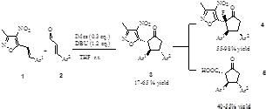
Figure 1: N-Heterocyclic carbene catalysed homoenolate addition.

References
1. A. Baschieri, L. Bernardi, A. Ricci, S. Suresh, M. F. A. Adamo, Angew. Chem. Int. Ed., 2009, 48, 9342.
2. A. J. Arduengo, R. L.Harlow, M. Kline, J. Am. Chem. Soc., 1991, 113, 361.
3. H. W. Wanzlick, E. Schikora, Angew. Chem. Int. Ed., 1960, 72, 494.

DEVELOPMENT OF ENANTIOSELECTIVE ORGANOCATALYTIC INTER [4+2] INTER [3+2] TANDEM CYCLOADDITION OF NITROALKENES
C. Del Fiandra , M. F. A. Adamo , and M. Moccia.

Centre for Synthesis and Chemical Biology (CSCB), Royal College of Surgeons in Ireland, Department of Medicinal and Pharmaceutical Chemistry, 123 St Stephen’s Green, Dublin 2, Dublin.
claudiadelfiandra@rcsi.ie

Figure 1. Study of tandem [4+2] [3+2] cycloaddition
Aim of this project is the establishment of suitable condition to react activated nitroalkenes 3-5, vinyl ethers 1 and acrylates in inter-molecular fashion under the catalysis of enantiopure ammoniumthioureas 6. The proposed process, which is formally a three component multicomponent reaction (3-MCR) furnishes important adducts 8 which could be converted for example to pyrrolizidines or other polycyclic fused aminoalcohols which are often bioactive as neuro protective or anti tumour. The tandem [4+2] [3+2] cycloaddition of nitroalkenes 3-5, vinyl ethers 1-2 and acrylates has been studied extensively by Denmark.¹ Despite of the exceptional versatility of the [4+2][3+2] tandem protocol mentioned above, an organo catalytic version has not been described. Herein we propose a program of study aimed at identifying suitable starting materials, catalysts and a set of optimised conditions to access compounds 8 in diasteroselective and enantioselective fashion.

References
1. S. E. Denmark and A. Thorarensen, Chem. Rev., 1996, 96, 1372.

Thermally stable and multifunctional organic molecules

Colm Delaney, Sylvia M. Draper
School of Chemistry, Trinity College Dublin

cdelane@tcd.ie

Since the synthesis of a Donor-Acceptor (D-A) system in 1986 by Tang et al.¹ the use of triphenylamine (TPA) compounds with conjugated bridges has been at the centre of D-π-A developments. These compounds offer a strongly electron-donating core along with readily substituted pendant phenyl rings (see Fig.1a). Outside of these essentially synthetic benefits they also exhibit high thermal and electrochemical stability, exceptional charge transport and efficient, tunable emission. Such attributes give them great promise in the development of multifunctional materials which avoid the detrimental effects that arise on the non-radiative recombination of excited states seen in OLED devices.

Incorporating ligand capability into the periphery of these molecules allows the chemist to merge hole-transport and emissive moieties and to create molecules with varied functionality. Dendrimeric ligands maximize the functionality of the molecule by offering repeating fluorophore sites, while retaining the orientation of the triarylamine propeller. The introduction of heteroatoms can also serve to promote metal-metal interactions between coordinated metal centres⁴ and can infer thermal-stability and efficient charge-transfer e.g. to a Ru(II)-terpyridine motif (Fig.1b). Herein we present our initial results in the generation of a range of heteroatom doped polycyclic aromatic hydrocarbons, which show increased excited-state lifetimes and quantum yields.

Figure 1: (a) Tuneable emission spectra of fluoranthene substituted TPA and (b) [Ru(tpy)₂]²⁺dendrimer.
References
(1) Tang, C. W. Applied Physics Letters 1986, 48, 183.
(2) Shirota, Y. Journal of Materials Chemistry 2000, 10, 1.
(3) Shirota, Y.; Kageyama, H. Chemical Reviews 2007, 107, 953.
(4) Onitsuka, K.; Ohara, N.; Takei, F.; Takahashi, S. Dalton Transactions 2006, 3693.
A General Method To Make P-Stereogenic Phosphorus Compounds

Kamalraj V. Rajendran, Kirill V. Nikitin and Declan G. Gilheany
Centre for Synthesis and Chemical Biology, School of Chemistry and Chemical Biology, University College Dublin, Belfield, Dublin 4, Ireland.

kamalraj.rajendran@ucd.ie

The dynamic resolution of tertiary phosphanes under asymmetric Appel^{[1,2]} conditions was monitored by NMR spectroscopy. Two sets of ¹H and the corresponding ³¹P signals were assigned to a pair of diastereomeric alkoxyphosphonium salt (DAPS) intermediates which can be reduced^{[3,4]} to phosphane borane (PB) or allowed to decompose via Arbuzov collapse to phosphane oxide (PO). It was found that the stereoselectivity in the asymmetric Appel process is determined during the formation of the DAPS, since the initial de of this species limits the final ee of both PO and PB. By observing the de of decomposing DAPS over time it was established that the relative decomposition rates of DAPS vary widely with alcohol/phosphane combination. As the decomposition progresses, diastereomeric enrichment of the remaining DAPS is typically observed indicating a higher decomposition rate constant for the minor diastereomer of the DAPS. This crucial observation was confirmed by reductive trapping of the unreacted enriched DAPS with NaBH₄ at different time intervals after the start of reaction, which gives progressively higher ee of PB product with time. Thus, slower formation and faster subsequent collapse of minor DAPS isomer are associated with two kinetic resolution steps furnishing up to 92 % ee material.
References
[1] E. Bergin, C. T. O'Connor, S. B. Robinson, E. M. McGarrigle, C. P. O'Mahony, D. G. Gilheany, J. Am.
Chem. Soc. 2007, 129, 9566-9567
[2] Rajendran, K. V.; Kennedy, L.; Gilheany, D. G., Eur.J. Org. Chem. 2010, 5642-5649.
[3] Rajendran, K. V.; Gilheany, D. G., Chem Commun. 2012, 48, 817-819.
[4] Rajendran, K. V.; Kudavalli, J. S.; Katherine, S. D., Gilheany, D. G., Eur. J. Org. Chem. 2012,
DOI:10.1002/ejoc.201200285.

Towards the development of glycoconjugate vaccines:
Synthesis of capsular polysaccharide structures of Cryptococcus neoformans.

R. Ulc, L. Guazzelli and S. Oscarson
Centre for Synthesis and Chemical Biology, School of Chemistry and Chemical Biology, University College Dublin, Belfield, Dublin 4, Ireland

rebecca.ulc@ucd.ie, stefan.oscarson@ucd.ie

Cryptococcus neoformans is an opportunistic fungal pathogen that causes severe diseases primarily in immunocompromised individuals (e.g. HIV positive patients).¹ C. neoformans is surrounded by a thick layer of capsular polysaccharides (CPS), which is an important virulence factor. In order to investigate the immunobiological properties of the fungal CPS and to develop glycoconjugate vaccines, chemically synthesised part structures of the fungal CPS are required. Currently, we are focusing on the synthesis of a thioglycoside hexasaccharide building block corresponding to serotype A structures of C. neoformans (Fig. 1). Our aim is to use the hexasaccharide as a building block in the construction of large oligosaccharide structures (octa-, deca- and dodecasaccharides) in order to determine structure and size of protective epitopes.²
Figure 1: Hexasaccharide building block
We present an improved synthetic pathway to the various building blocks and their assembly to the hexasaccharide. A reliable methodology to access structurally related thioglycoside building blocks has been developed previously in our group.^{3,4,5}

References
1. E. Brummer, Mycopathologia, 1999, 143, 121-125.
2. S. Oscarson, M. Alpe, P. Svahnberg, A. Nakouzi, A. Casadevall, Vaccine, 2005, 23, 3961–3972.
3. M. Alpe, P. Svahnberg, S. Oscarson, J. Carbohydr. Chem, 2003, 22, 565-577.
4. M. Alpe, P. Svahnberg, S. Oscarson, J. Carbohydr. Chem, 2004, 23, 403-416.
5. J. Vésely, L. Rydner, S. Oscarson, Carbohydr. Res., 2008, 343, 2200-2208.

Settled at Last: The Final Word on The Wittig Reaction Mechanism
P. A. Byrne, D. G. Gilheany.
Centre for Synthesis & Chemical Biology, UCD, Belfield, Dublin 4, Ireland

Declan.Gilheany@ucd.ie

The true course of the lithium salt-free Wittig reaction has long been a contentious issue in organic chemistry [1]. Herein we report an experimental effect that is common to all of the three major phosphonium ylide classes (non-stabilized, semi-stabilized and stabilized): there is consistently raised selectivity for cis-oxaphosphetane and its derived products (Z-alkene and erythro-β-hydroxyphosphonium salt) in reactions involving aldehydes bearing heteroatom substituents in the β-position [2]. The effect operates with both benzaldehydes and aliphatic aldehydes and is shown not to operate in the absence of the heteroatom substituent on the aldehyde. The discovery of an effect that is common to reactions of all ylide types strongly argues for the operation of a common mechanism in all lithium salt-free Wittig reactions. The results are shown to be most easily explained by the [2+2] cycloaddition mechanism proposed by Vedejs and co-workers [3] as supplemented by Aggarwal, Harvey and co-workers [4], thus providing strong confirmatory evidence in support of that mechanism. Notably, a co-operative effect of ortho-substituents in the case of semi-stabilized ylides is confirmed and is accommodated by the cycloaddition mechanism. The effect is also shown to operate in reactions of triphenylphosphine-derived ylides, and has previously been observed for reactions under aqueous conditions [5], thus for the first time providing evidence that kinetic control is in operation in both of these cases.
Figure 1. Wittig reactions of β-heteroatom substituted benzaldehydes are highly Z-selective, and occur through a [2+2] cycloaddition transition state.

References

[1] Johnson, A. W. Ylides and Imines of Phosphorus (1993), Wiley; New York, chapters 8 and 9; pp. 221-305.

[2] Byrne, P. A.; Gilheany, D. G. J. Am. Chem. Soc. 2012; accepted for publication; manuscript ID ja-2012-00943z.R1.

[3] Vedejs E.; Marth, C. F. J. Am. Chem Soc. 110 (1988) 3948; Vedejs, E., Fleck, T. J. Am. Chem. Soc. 1989, 111, 5861.

[4] Robiette, R.; Richardson, J.; Aggarwal V. K.; Harvey, J. N. J. Am. Chem. Soc. 2006, 128, 2394.

[5] Dunne, E. C.; Coyne, E. J.; Crowley, P. B.; Gilheany, D. G. Tetrahedron Lett 2002, 43, 2449.

Formal total synthesis of (+)-Inthomycin C through O-directed hydrostannation
M. Grabski , K. J. Hale
The School of Chemistry & Chemical Engineering and the CCRCB, Queen’s University Belfast, Stranmillis Road, Belfast, BT9 5AG Northern Ireland, UK

mgrabski01@qub.ac.uk

(+)-Inthomycin C (1) belongs to a large family of active natural products containing CH₂-interrupted oxazole-triene moiety, some of which were found to display selective antimicrobial, antitumour or herbicidal activity¹. In this poster we describe our approach to the formal total synthesis of 1.
Scheme 1: Retrosynthetic analysis of (+)-Inthomycin C
Our synthesis started with preparation of the alkyne 8 by Carreira’s alkynylation of 9. Next, the alkyne 8 was reacted with Ph₃SnH under conditions developed in Hale’s group² giving 7 almost exclusively as a single regioisomer in a quantitative yield. Next, the stannane 7 was converted into a corresponding vinyl iodide in the presence of N-iodosuccinimide, which thereafter was methylated under modified Stille conditions. Intermediate 6 was subsequently converted into the diene 5 in a very good yield. Then, regioselective dihydroxylation of 5 followed by olefin oxidative cleavage afforded the enal 4. Thereafter it was subjected to Hodgson stannoolefination³ in order to produce 3 in moderate yield as a single stereoisomer, thus completing the formal total synthesis of 1.
References
- R. J. K. Taylor, C. Donald, Tetrahedron, 2008, 64
- K. J. Hale, P. Dimopoulos, S. Manaviazar, Org. Lett., 2005, 7(24), 5369-5372
- D. M. Hodgson, A. M. Foley, L. T. Boulton, P.J.Lovell, G.N. Maw, J. Chem. Soc., Perkin Trans. 1, 1999, 2911-2922.

Design, synthesis and catalytic application of 4,4-Bis(Oxazoline) ligands

Nadine Mc Cleary, Patrick O’Leary.

SMACT, School of Chemistry, National University of Ireland, Galway.
nadine.mccleary@gmail.com

We have prepared novel bis(oxazoline) ligands which when coordinated to a metal have two chiral centres within the metallocycle¹. We will report on the synthesis and structure of these new BOX Ligands (AraBOX) and on their catalytic activity in a variety of transition metal catalysed reactions (Fig 1)

Figure 1

Metal complexes of 2,2-bis(oxazoline) ligands are well established asymmetric catalysts applicable to a wide variety of synthetically important reactions such as cyclopropanation, Diels-Alder cycloaddition, ene reactions, aldol reactions etc (Fig 2). Catalytically active complexes of these ligands have been reported using metals such as Fe, Cu, Co, Mg, Zn and Pd. A wide variety of ligands based on this structural motif have been reported². Such variations have largely concentrated on the functionalisation of the oxazoline rings and some variation at the bridgehead linkage.
Our aim is to create a new family of bis(oxazoline) ligands where the chiral centres were moved close to the bridgehead. This would have the consequence of introducing chirality closer to the reactive metal centre. To that end we have successfully synthesised 4,4-bis(oxazoline) ligands which combine similar coordination chemistry to that of the 2,2-bis(oxazoline) ligands with the intriguing feature of having the chiral centres of the ligand internal to the metallocycle in the catalytic complex.

Figure 2

References
1. Frain, D.; Kirby, F.; McArdle, P.; O'Leary, P. Synlett 2009, 2009, 1261,1264.
2. Desimoni, G.; Faita, G.; Jørgensen, K. A. Chemical Reviews 2006, 106, 3561-3651.
Specific Ion Effects on Protein Interactions in the E. coli Cytosol

C. Kyne, P. B. Crowley

School of Chemistry, National University of Ireland Galway, University Road, Galway, Ireland.

c.kyne1@nuigalway.ie

Inside the cell, a complex mixture of macromolecules assembles to form macromolecular interaction networks that remodel in acclimation of the ever-changing cellular environment (1). Traditional protein characterisation methods involve pure dilute samples with the result that less is known about cellular protein properties. We describe a size exclusion chromatography (SEC) technique that allows for the investigation of protein interactions in E. coli cell lysates at near physiological protein concentrations (2).The interactions of the arginine-rich Tat nuclear localization signal (NLS) in the ΔTat-GB1 fusion protein were studied (Fig. 1). ΔTat-GB1 proved sticky and eluted from the column with a high apparent molecular weight at low ionic strength, implying that it participates in multi-protein complexes with E. coli cytosolic proteins (Fig. 1). To identify the interaction propensities of the NLS, a number of ionic species were employed as SEC buffer components at ionic strengths of 0.1 and 0.2. Biologically-relevant cations were the most efficient at disrupting ΔTat-GB1 containing complexes (Fig. 1). Our results also show that monoanions cannot compete with the acidic surface patches of E.coli proteins for interactions with the Tat NLS. However, citrate appears to effectively compete with such patches suggesting the importance of local charge “concentration effects” in driving intracellular self assembly. Our results highlight the need for biologically stringent buffers in the identification of functionally productive binding partners through interaction profiling methods.
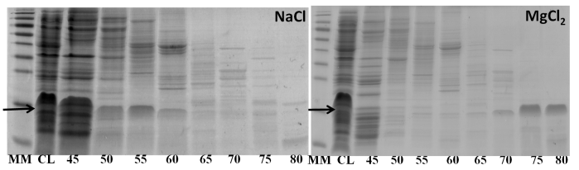
Figure 1: SDS-PAGE generated ΔTat-GB1 elution profiles in NaCl (left) and MgCl₂ (right), are shown. The gel lanes are labelled; MM: molecular weight marker; CL: cell lysate; 45–80: fraction volume (mL). The migration position of ΔTat-GB1 (7.7 kDa) is marked.

References
- L. M. Gierasch, A. Gershenson, Nature Chemical Biology, 2009, 5, 774-777.
- P. B. Crowley, E. Chow, T. Papkovskaia, ChemBioChem, 2011, 12, 1043-1048.

Systematic study into substituent’s effect on the Performance of a series of therapeutic Ru(II) complexes.
Laura Perdisatt ¹, Christine O’ Connor ² and Luke O’ Neill¹.
¹Focas Institute, Dublin Institute of Technology, Camden Row, Dublin 8.
²School of Chemical and Pharmaceutical Sciences, Dublin Institute of Technology, Kevin St., Dublin 8

laura.perdisatt@dit.ie,

The photoactivation of Ruthenium (II) complexes as therapeutic drugs has recently escalated in interest. Hence to maximise the potential of ruthenium complexes as suitable candidates for therapeutic treatment the processes that govern photoactivation must be well understood and optimised.
The aim of this work is to develop structure property relationships for systematically varied series of phendione ligands based Ru(II) complexes allowing optimization of the favourable photonic characteristics for potential applications (active therapeutics, solar concentrator etc…). A series of novel octahedral Ru(II) complexes with varying spectator ligands, (L1) 2,2’-bipyridine, 1,10-phenanthroline and 2,2’-biquinoline and different electronegative polypyridyl ligands (L2), of the form [Ru(L1)₂L2](PF₆)₂ were synthesised.
The photophysical properties of the complexes were investigated using transient, steady-state and vibrational spectroscopy. Establishment of the complexes photophysical properties allowed the formularization of structure property relationships elucidating the variation of the electronic bandgap (MLCT), emission band-gap, luminescence yield, Stokes shift and luminescence lifetime with the systematic variation of bystander/polypyridyl ligand.
Future work will included monitoring the method/propensity for DNA binding as function of the systematic structural changes and possible correlation with photophysical parameters.

Synthesis and characterisation of novel pyrazine-derived dithiolene complexes as models for the pyranopterin ligand in the molybdenum cofactor
C. Schulzke, M. Zubair
Department of Chemistry, Trinity College, University of Dublin, Ireland
zubairm@tcd.ie

Molybdenum cofactor (Moco, see Figure 1) deficiency is a human disease in which lack of molybdenum cofactor results in a broad spectrum of neurological problems.¹ Absence of Moco in infants leads to death within months due to lack of active sulfite oxidase. N-heterocyclic derived dithiolene ligands are present in a large number of biologically active molybdenum and tungsten containing enzymes such as sulfite oxidase, aldehyde ferredoxin oxidoreductase etc. There are reports in the literature of model complexes of Moco which contain dithiolene chelates substituted by Pterin or other closely related N-heterocycles such as quinoxaline.² However, a true chemical analogue in a molybdenum and tungsten complex for this type of ligand still remains a huge challenge.

Figure 1: The molybdenum and tungsten cofactors.
In the present study, pyrazine and quinoxaline based compounds were synthesised using the Sonogashira coupling reaction with the chloro-substituted pyrazine and quinoxaline derivatives. In order to synthesise model complexes, alkynyl-substituted compounds were reacted with (Et₄N)₂[MoO(S₄)₂] but no reaction was observed. Interestingly, the reaction of alkynyl-substituted compound with (Et₄N)₂[MoO(S₄)₂] in the presence of elemental sulfur showed the isolation of novel quinoxaline-derived pentathiepins. Another attempt was made to synthesise the desired model complexes in which acetyl pyrazine was used to prepare the corresponding pyrazine-derived dithiolene-2-one ligand and was further reacted with the molybdenum or tungsten metal salts to form their corresponding metal complexes. The chemical structures of the ligand, its synthetic intermediates and its respective complexes were established using spectroscopic techniques (IR, ¹H and ¹³C-NMR, MS), as well as elemental analysis and X-ray crystallography where possible.
References
1. W.-H. Tan, F. S. Eichler, S. Hoda, M. S. Lee, H. Baris, P. E. Grant, K. S. Krishnamoorthy, V. E. Shih and C. A.
Hanley, Padriatics, 2005, 116, 757-766.
2. F.-A. Alphonse, R. Karim, C. Cano-Soumillac, M. Hebray, D. Collison, C. D. Garner and J. A. Joule,
Tetrahedron, 2005, 614, 11010-11019.

Analysis of Amorphous and Crystalline Sulfamerazine

P. MacFhionnghaile¹, Y. Hu¹, A. Erxleben¹, and P. McArdle¹
1. School of Chemistry, NUI Galway.

p.macfhionnghaile1@nuigalway.ie

The detection and quantification of amorphous and crystalline content in pharmaceutical solids is an area of increasing interest in recent years due to the different properties of the amorphous and crystalline phases. Amorphous and crystalline states can differ for example in stability, solubility and bioavailability. Because of this it is necessary to have accurate means to quantify the different solid state forms, and to understand their formation and properties ^{[1]}.
In this study the amorphous phase of sulfamerazine was produced, for the first time via cryo-milling (Figure 1). The effects of cryo-milling on the two polymorphs of sulfamerazine, form I and form II, were investigated and the stability of the amorphous phase obtained from both forms was studied. X-ray powder diffraction (XRPD), near-infrared (NIR) and infrared (IR) spectroscopy combined with multivariate analysis were used to quantify amorphous and crystalline sulfamerazine in binary mixtures (amorphous / form I and amorphous / form II). The best calibration model was obtained for the low content analysis of form II in form I with data pre-processed using the 2nd derivative of the spectra and standard normal variate (SNV) transformation, giving root mean square error of calibration (RMSEC), root mean square error of validation (RMSEV) and root mean square error of prediction (RMSEP) values of 0.24%, 0.28%, and 0.24%.
Figure 1: XRPD of cryo-milled sulfamerazine taken at different intervals
References
1. G.D.P. Buckton, Int. J. Pharm., 1999, 179, 141-158

Acknowledgements:
Financial support from Science Foundation Ireland (funding of the Solid State Pharmaceuticals Cluster) is gratefully acknowledged.

Ferromagnetic exchange in twisted, oxime-bridged [Mn(III)₂] and [Mn(III)₂Zn(II)₂] dimers
Edel Houtonª, Euan K. Brechin^{b}, Alan G. Ryderª and Leigh F. Jonesª.

ªSchool of Chemistry, University Road, National University of Ireland, Galway, Ireland.
^{b}EaStCHEM School of Chemistry, The University of Edinburgh, The Kings Buildings, West Mains Road, Edinburgh, EH9 3JJ, UK.

e.houton1@nuigalway.ie

Single-molecule magnets (SMMs) are a family of molecular species that can retain magnetization below a blocking temperature, in the absence of a magnetic field. Too date, a large number of molecules exhibiting the phenomenon of single-molecule magnetism have been synthesized. These mono-disperse magnetic materials consist of a collection of paramagnetic transition metal ions bound by a range of organic ligands. This class of compound represent the smallest possible magnetic storage devices, through storage of information in a single molecule rather than in an array of particles.
Developing upon previous work by Jones / Brechin and co-workers,¹ we report here the developement of a family of Manganese based SMMs. Two complexes are described which act as simple model complexes, with which to examine the magneto-structural relationship in polymetallic, oxime-bridged Mn^{III} complexes. Dc magnetic susceptibility studies reveal that ferromagnetic exchange is mediated through their heavily twisted Mn-O-N-Mn moieties (Fig. 1).²
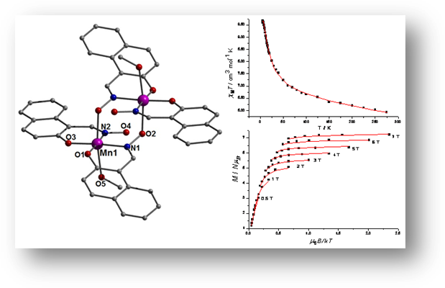
Figure 1: (left) A [Mn₂] Ferromagnet (top right) Plot of the χ_{M}T product of [Mn₂] vs. T (bottom right) Plot of reduced magnetization of [Mn₂]

References
1. R. Inglis, C. J. Milios, L. F. Jones, S. Piligkos and E. K. Brechin, Chem. Commun., 2012, 48, 181-190.
2. R. Inglis, E. Houton, J. Liu, A. Prescimone, J. Cano, S. Piligkos, S. Hill, L. F. Jones and E. K. Brechin, Dalton Trans., 2011, 40, 9999-10006.


Intercalation of Ruthenium (Ru) complexes into double stranded DNA.

S. Roche¹, T.E. Keyes¹ and R.J. Forster¹
1. National Centre for Sensor Research, Dublin City University, Glasnevin, Dublin 9.

stephenroche23@gmail.com

The interaction of Ru complexes with double stranded DNA (dsDNA) can lead to significant changes in the emission maximum intensity of the metal complex. These changes are advantageous as it enables DNA hybridisation to be detected (Fig. 1A). The luminescent characteristics of the metal complexes [Ru(bpy)₂pic-COOH]²⁺ and [Ru(dppz)₂pic-COOH]²⁺ were examined using double stranded salmon testes DNA (ST-DNA). These metal complex dyes show the “light switch effect” which occurs when dsDNA is present in solution. Using [Ru(bpy)₂pic-COOH]²⁺, the emission intensity (I_{EM}) was shown to more than double with the addition of increasing concentrations of ST-DNA and reaching saturation at a mole fraction ratio of approximately 1:3 (Ru:DNA). [Ru(dppz)₂pic-COOH]²⁺ showed a similar increase but at a much lower I_{EM} value.
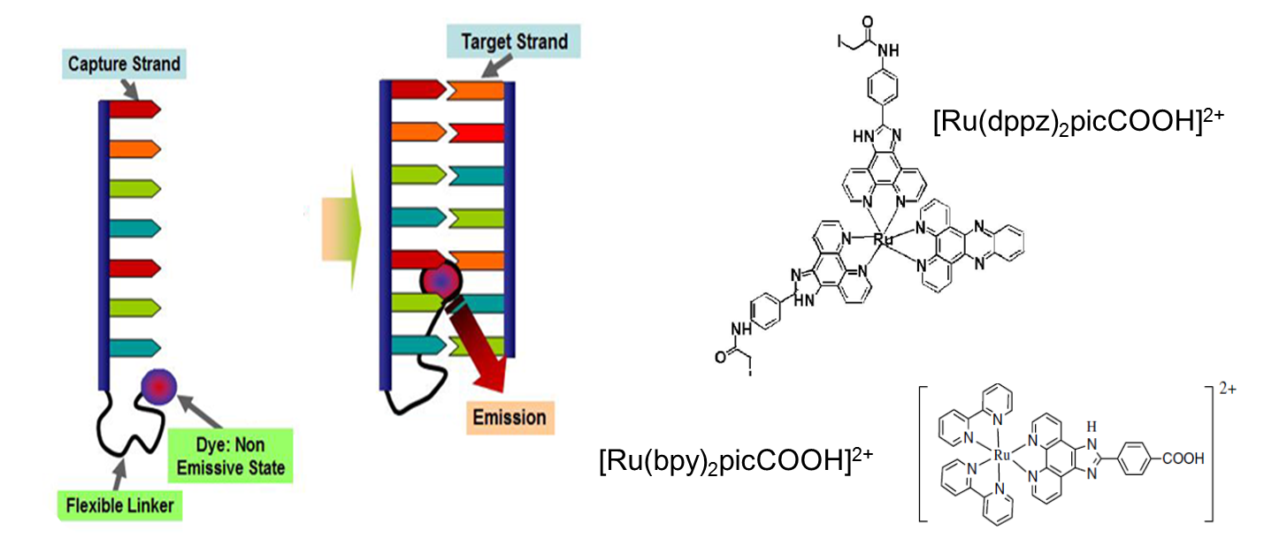
(a)
(b)

Figure 1: (a) Metal complex luminescence changes initiated by the hybridisation of DNA. (b) The structures of the “light switch effect” Ru complexes.

This material is based upon works supported by the Science Foundation Ireland under Grant No. 10/IN.1/B3021.

Thermophysiochemical properties of pure and water-saturated ionic liquids
Simon Gallagherª, Jason Rigby^{b}, Ekaternina Izgorodina^{b}, Kevin Fraserª, Dermot Diamondª and Doug MacFarlane^{b}
ª CLARITY: Centre for Sensor Web Technologies, National Centre for Sensor Research, Dublin City University, Dublin 9, Ireland.^{b} School of Chemistry, Monash University, Wellington Road, Clayton Vic 3800, Australia.

We have previously reported into the extent of structuring in ILs using photochromic molecular probes¹. In order for Ionic Liquids (ILs) to be fully utilized to their potential, it is necessary to have a complete understanding of their physical properties. In this study we investigated the thermophysical interactions in several pure and water-saturated ionic liquids being hydrophilic and hydrophobic in nature, namely 1-alkyl-3-methyl imidazolium and trihexyltetradecylphosphonium family of ILs. The density, viscosity and conductivity of pure and water-saturated imidazolium and phosphonium-based ILs were measured over a broad temperature. Moreover, interactive and binding energies of the studied imidazolium ILs in the presence of H₂O molecules were calculated using Gaussian and compared with experimental Raman spectroscopy of the same imidazolium ILs, with and without the presence of saturated water.
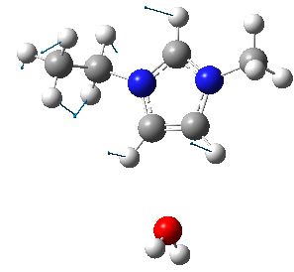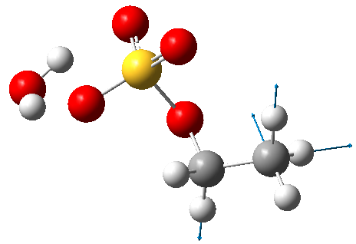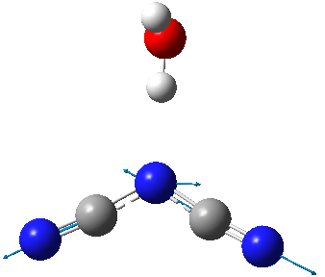
(A)
(B)
(C)

Figure 1. (A) 1-Alkyl-3 methyl-imidazolium cation, (B) ethyl-sulfate and (C) dicyanamide anions in the presence of H₂O molecule.

Reference
1 Byrne, Robert and Coleman, Simon and Gallagher, Simon and Diamond, Dermot (2010) Designer molecular
probes for phosphonium ionic liquids. Physical Chemistry Chemical Physics, 12 (8). pp. 1895-1904. ISSN
1463-9076

Silioxane Polymers Containing Ag(I) and Cu(II) Ions: Synthesis and Anti-fungal Activity

T. Owens^{1,2}, B. Creaven¹, M. Walsh¹ and M. McCann²

1. Department of Science, Institute of Technology Tallaght, Dublin 24
2. Chemistry Department, National University of Ireland, Maynooth

triciaeowens@itnet.ie

Nosocomial infection is frequently the result of biofilm colonisation of medical devices and implants. Biofilm growth begins when microorganisms adhere to and grow on the surface of the device, and once a biofilm has developed it is extremely difficult to destroy. In addition to causing wound infections in patients nosocomial infections cost the health service in Ireland €233 million euro last year¹. Silver(I) and copper(II) ions are toxic to pathogenic fungi and bacteria without compromising the human immune system. It is hoped that by incorporating such metal ions into the silicone polymers from which these medical devices are made they will become less susceptible to biofilm growth.
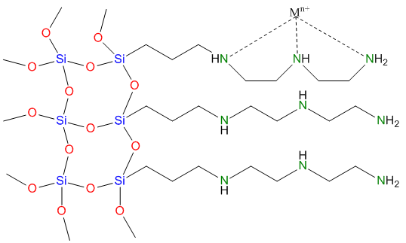
The amino functionalised monomers, (3-aminopropyl)triethoxysilane and (3-trimethoxysilylpropyl)diethylene-triamine, polymerise in the presence of metal ions (Ag(I)- and Cu(II)) to give metallo-silicone polymers (Fig. 1). These metallo-silicone polymers display good growth inhibition against the fungal pathogen, Candida albicans, and could possibly be used as a composite material in the fabrication of sterile surfaces.

Figure 1: Coordination of metal ions in the polymer derived from (3-aminopropyl)triethoxysilane.

Reference
1. O. Cahill, Healthcare-Acquired Infections (HCAIs) in Ireland, Arann Healthcare Ltd., 2011.

Computational design of glycomimetics to inhibit pathogen-host interactions

H. Smith¹, J. Hendel¹ and R. J. Woods^{1,2}
1. School of Chemistry, National University of Ireland, Galway
2. Complex Carbohydrate Research Center, University of Georgia, 315 Riverbend Road, Athens, GA 30602, USA

h.smith4@nuigalway.ie

Many pathogens, such as avian influenza, H. pylori and S. pneumonia, employ cell-surface glycans which terminate in Neu5Ac-α-(2-3)-Gal as their adhesion partner.¹ As a result, a glycomimmetic anti-adhesive drug based on this structure could potentially prevent infection.
In this project, sialylated galactose (α-Neu5Ac-(2,3)-Gal) will be employed as a scaffold in the design of high-affinity inhibitors of influenza A virus adhesion. We will employ advanced computational methods to focus the number of glycomimetic synthetic targets to a select few that have the highest probability to block influenza adhesion and infection. Several glycomimetic lead scaffolds are currently being synthesised and their ability to inhibit avian influenza haemagglutinin will be assayed.
The computational methods which are being used include molecular dynamics (MD) and molecular mechanics - Poisson Boltzmann solvation approximation (MM-PBSA) calculations. MM-PBSA is used to estimate the binding free energy. Substituent remodelling was carried out using BOMB to scan libraries containing over 500 drug-like substituents.²

References
1. I. Ofek, D. L. Hasty and N. Sharon, FEMS Immunology & Medical Microbiology, 2003, 38, 181-191.
2. W. L. Jorgensen, Accounts of Chemical Research, 2009, 42, 724-733.

Investigation of the spontaneous grafting of polycyclic aryldiazonium salts at carbon surfaces
D. M. Murphy ¹, R. J. Cullen ¹, E. M. Scanlan ¹, P. E. Colavita ¹
1. School of Chemistry, University of Dublin Trinity College, College Green, Dublin 2, Ireland.

murphd31@tcd.ie

Aryldiazonium salts are versatile reagents that can be utilized to modify the surface chemistry of a wide variety of substrates including metals, carbon materials and polymers. Aryldiazonium cations can be grafted at surfaces either via electroreduction, or spontaneously from solution. Spontaneous attachment is particularly advantageous because no electrical contact is required thus allowing researchers to broaden the application of surface modification using aryldiazonium chemistry to materials which are insulating and even to nanoparticles in suspension. For this reason there is great interest in understanding and controlling the kinetics of spontaneous grafting. This work aims at investigating the spontaneous attachment of polycyclic aryldiazonium salts at various carbon surfaces. We have focused on the adsorption kinetics of polycyclic aryldiazonium salts at different carbons and examined how their grafting rate and yield depends on the structure and stability of the salt as well as on the electronic properties of the surface onto which the spontaneous grafting is occurring.

An in situ study of the spontaneous attachment of two polycyclic aromatic positional isomers and their monocyclic analog at amorphous carbons of varying graphitic sp² content is reported. We monitored the grafting using a home built reaction cell and Attenuated Total Internal Reflection Fourier Transform Infrared spectroscopy (ATR-FTIR). In situ results were complemented by electrochemical ex situ studies in order to determine surface chemisorption rates. The adsorption rates of the two positional isomers were found to be significantly different at amorphous carbon surfaces. We show, via electrochemical and UV-Vis measurements, that this disparity is due to a shift in reduction potential of the aryldiazonium salts. However, any differences in adsorption rate can be eliminated by increasing the metallic character of the amorphous carbon surface. These results suggest that aryldiazonium salt adsorption rates at carbon surfaces can switch from being controlled by molecular electron accepting properties to being controlled by surface electron donating properties. This work highlights the importance of substrate choice in spontaneous grafting reactions and provides further mechanistic insight into the reliance of adsorption on structural and substrate composition.

Nanostructured Polypyrrole Films for Polyoxometallate Immobilisation

David Ward¹*, Eithne Dempsey¹, and Timothy McCormac²

¹Centre for Research in Electroanalytical Technologies, Dept. Science, ITT Dublin, Tallaght Dublin 24, Ireland.
²Electrochemistry Research Group, Dundalk Institute of Technology, Dundalk, Co. Louth, Ireland.

davidward86@itnet.ie Tel: 00 353 1 4042742

Novel nanostructured conducting polymer films were fabricated on conducting surfaces using (i) a two step electropolymerisation technique to form orientated nanowire arrays under potentiostatic conditions and (ii) nanosphere lithography – each with the incorporation of polyoxometallates as the doping anion. The resultant films were then characterised using electrochemical and surface techniques. Two main polyoxometallate species were employed here - the first is derived from the Dawson anions [P₂W₁₈O₆₂]^{n-} where one of the tungsten oxo atoms has been replaced by a transition metal cation - Fe³⁺ substituted K₇P₂W₁₇O₆₁(Fe³⁺.OH₂) and the second is a Copper substituted Krebs POM K₁₀[Cu₅(OH)₄(H₂O)₂(A-α-SiW₉O₃₃)₂] which was formed from a Keggin type polyoxometallate precursor α-[SiW₁₁O₃₉]⁸⁻. These inorganic clusters possess stable redox states, can accept/donate multiple electrons without structural deformation, and their redox behaviour can be tuned, making them attractive as electrocatalytic materials. Sensing applications of the redox active nanostructured polyoxometallate (POM) functionalised surfaces will be explored following optimisation of loading and growth conditions.

Mechanism of ALD Reaction for Cu

Gangotri Dey, Simon D. Elliott

Tyndall National Institute, University College Cork, Dyke Parade, Cork, Ireland

gangotri.dey@tyndall.ie
Atomic layer deposition (ALD) is a process for depositing highly uniform and conformal thin films by alternating exposures of a surface to vapours of two chemical reactants. ALD processes have been successfully demonstrated for many compounds but for very few pure metals. Here, we present a quantum mechanical study of reactions underlying the ALD of copper (transition metal). Copper has attracted the attention as electronic interconnect because of its good conductivity and superior resistance to electro-migration. But a complete thin layer (<2nm) is very difficult to deposit because of its high tendency to agglomerate. A new ALD process for Cu has been developed by Lee et al.¹ based on the following transmetallation reaction:
Cu(dmap)_{2(g)} + ZnEt_{2(g)} → Cu_{(s)} + Zn(dmap)_{2(g)} + Butane_{(g)}
The applicability of transmetallation ALD has been extended to other ligands and co-reagents². A solution phase study revealed3 the possible mechanism and reaction intermediates. We have studied theoretically how the transmetallation mechanism works via quantum chemical calculations using the TURBOMOLE package using Density Functional Theory (DFT) as a key tool. The mechanism in the solution phase²⁻³ as well as during the ALD process¹ has been examined by both the intrinsic reactivity of the transmetallation precursors (gas-phase model) and by explicitly modelling how they react with a copper metal surface (cluster model of surface), using geometry optimisation and molecular dynamics at the DFT level. We have seen that flexibility of the ligands in the precursors aids copper deposition. The intermediate LZnEt can form and accumulate in the system, and this can lead to zinc contamination in the film. This is because zinc and copper are close to each other in the electrochemical series.

References
1. Lee, B. H.; Hwang, J. K.; Nam, J. W.; Lee, S. U.; Kim, J. T.; Koo, S.-M.; Baunemann, A.; Fischer, R. A.; Sung, M. M., Low-Temperature Atomic Layer Deposition of Copper Metal Thin Films: Self-Limiting Surface Reaction of Copper Dimethylamino-2-propoxide with Diethylzinc. Angewandte Chemie International Edition 2009, 48 (25), 4536-4539.
2. Vidjayacoumar, B.; Emslie, D. J. H.; Clendenning, S. B.; Blackwell, J. M.; Britten, J. F.; Rheingold, A., Investigation of AlMe3, BEt3, and ZnEt2 as Co-Reagents for Low-Temperature Copper Metal ALD/Pulsed-CVD. Chemistry of Materials 2010, 22 (17), 4844-4853.
3. Vidjayacoumar, B.; Emslie, D. J. H.; Blackwell, J. M.; Clendenning, S. B.; Britten, J. F., Solution Reactions of a Bis(pyrrolylaldiminate)copper(II) Complex with Peralkyl Zinc, Aluminum, and Boron Reagents: Investigation of the Pathways Responsible for Copper Metal Deposition. Chemistry of Materials 2010, 22 (17), 4854-4866.

Development of efficient, cost effective anode materials for large scale hydrogen production via alkaline water (photo) electrolysis

Ian Godwin, Anja Cakara, Michael E.G. Lyons,
Trinity Electrochemical Energy Conversion and Electrocatalysis Group, School of Chemistry, Trinity College, Dublin 2 godwini@tcd.ie
Hydrogen production via alkaline water electrolysis has the potential to offer a clean and environmentally inoffensive route to large scale production of hydrogen gas for a future hydrogen economy. However, one of the main obstacles in realizing this technology is in the large anodic oxygen evolution reaction (OER) overpotential required for water electrolysis. The development of cost effective and efficient OER anode materials is currently a hot topic in research due to the inhibiting cost of RuO₂ and IrO₂ which act as ideal OER anode materials. Over the past several years the Trinity Electrochemical Energy Conversion and Electrocatalysis (TEECE) Group has proposed the use of low cost oxides, hydroxides and oxyhydroxides of first row transition metals as competitors to these rare metal oxide materials due to their cost being significantly lower, their improved stability in alkaline solution and their relatively low overpotential.
In this work we compare different methods of preparation of electrocatalytically active nickel hydroxides by use of potential mulitcycling of nickel metal in alkaline solution and by electrodeposition of nickel from solution and their effect on the OER and redox switching of the nickel system . We also show the effect of varying the deposition substrate and give some insight into the mechanistic detail of oxidative water splitting by employing electrochemical methods such as cyclic voltammetry, Tafel analysis and potential step techniques. As demonstrated in fig. 1 we can increase the OER rates significantly by growing catalytic hydroxide films on the substrate. Also, in the Tafel plots as shown in fig. 2, hydrated nickel and iron hydroxide electrodes compare favourably with current state of the art anode materials (RuO₂ and IrO₂ )for use in alkaline water electrolysis.
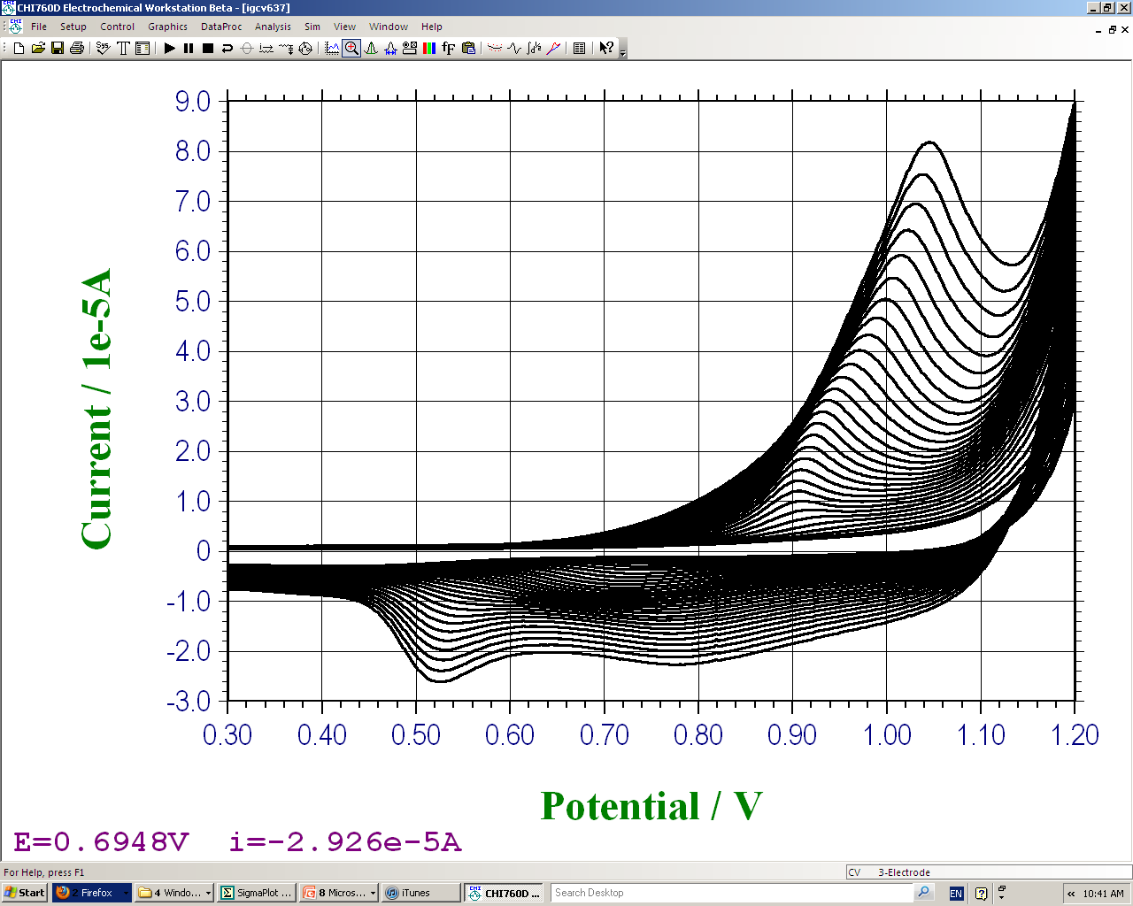
Fig. 1
Fig. 2
Fig. 1 Au working electrode: Ni electrodeposited by multicycling between limits -0.9-1.2 V vs SCE for 30 cycles at 50 mV/s in solution of 0.1 M NiSO₄ 0.1 M NaAc 0.001 M KOH. Fig. 2 Tafel plots (normalized for active surface area) recorded under active oxygen evolution conditions comparing RuO₂ and IrO₂ with multicycled Nickel and Iron electrodes, 1.0 M NaOH.

Modified carbon paste composites for electrochemical detection of dopamine.

GAMA T. GNAHORE*, J. COLLERAN and T. VELASCO-TORRIJOS

National University of Ireland, Maynooth, Co. Kildare, Ireland

gamatheophile@yahoo.fr

The preparation of modified carbon paste composites and their electrocatalytic oxidation to dopamine (DA) in 0.1M PBS at pH 6.8 were presented.
Several parameters such as analyte concentration, amount of modifier, scan rate variation were investigated by cyclic voltammetry (CV) and differential pulse voltammetry (DPV). The modified electrode was employed for the simultaneous determination of dopamine and serotonin in the presence of 1mM ascorbic acid. The overlapped anodic peaks of the two compounds in solution mixture can be separated.
The proposed sensor showed improved analytical performance characteristics in the catalytic oxidation of DA compared with the non-modified electrode.
The peak currents were proportional to the concentration of DA with a lowest detection limit of 5×10^{–7} M.

The effect of modifier concentration and the addition of additives to modifiers in Supercritical Fluid Chromatography (SFC)
O. Gaffney*¹, D. Connolly¹, M. O’Gorman², V. Nelson²
¹Irish Separation Science Cluster (ISSC), Dublin City University, Ireland
²Pfizer Process Development Centre (PDC), Loughbeg, Ringaskiddy, Co Cork, Ireland

“Green” chromatography is generally defined as any chromatographic method which generates low or zero levels of solvent waste, and supercritical fluid chromatography (SFC) is therefore an ideal candidate since in many cases separations can be achieved in 100 % sCO₂ mobile phases. Generally speaking, SFC can be considered to be a derivative of normal phase chromatography with the added advantage of lower viscosity and much higher diffusivity of supercritical fluids leading to faster mass-transfer. Both phenomena result in sharper chromatographic peaks at higher linear velocities, with optimum mobile phase velocities being up to three times higher relative to conventional liquid chromatography.
Due to the unique solvating power of sCO₂, SFC also offers orthogonal selectivity relative to reversed phase separations. Therefore we will report upon recent investigations into the improvements in sample throughput and complementary selectivity which can be achieved using SFC for the analysis of pharmaceutical compounds.
An extensive study was carried out on the effect of organic modifier concentration and mobile phase additives on the retention and separation of a selected Pfizer drug product and related impurities using a range of stationary phases commonly employed in SFC (specifically: bare silica, amino, diol and ethylpyridine). All separations were carried out on an Agilent 1260 Infinity Analytical SFC consisting of an Aurora SFC Fusion A5 and a modified Agilent 1260 Rapid Resolution LC. Methanol or acetonitrile were selected as organic modifiers at concentrations ranging from 2 % to 20 % and mobile phase additives employed for comparative purposes were ammonium acetate, triethylamine and trifluoroacetic acid. Significant effects upon selectivity (elution order) were observed when mobile phase composition was varied (using isocratic conditions). Cyano and bare silica stationary phases exhibited the best selectivity for the pharmaceutical compounds chosen for study, with significant reductions in runtime. For example, a 36% decrease in analysis time was observed with a cyano column and methanol as organic modifier when compared to an existing validated reversed phase HPLC assay. Resolution could still be maintained between all peaks in the chromatogram with resolution of greater than 3.5 between peaks 1 and 2 and greater than 2.1 between peaks 2 and 3. Interestingly, elution order could be readily controlled in order to achieve orthogonal selectivity relative to reversed phase chromatography. Preliminary results of the development of an impurities assay for the same drug compound using a reversed phase sub-2 µm core shell stationary phase will also be presented.

Tar Analysis from Fluidized Bed Gasification of energy crop Miscanthus giganteus

A. Horvat, M. Kwapinska and J.J. Leahy

Carbolea Biomass Research Group, Chemical and Environmental Sciences Dept., University of Limerick.

alen.horvat@ul.ie.

Gasification is nearly 200 years old thermochemical technique, where organic solid feedstock is converted into mixture of gases (producer gas). As an undesirable by-product tar is formed. Tar is limiting factor in all further producer gas utilization, like catalyst deactivation in Fischer–Tropsch diesel synthesis.¹ In Carbolea research group at University of Limerick gasification of energy crop Miscanthus giganteus is carried out. As a part of the study on gasification of biomass tar from producer gas is being analysed. Analytical work is devided in two sections. The first section is tar collection. The second section is tar analysis. Tar collection methods are solid phase adsorption (SPA) and tar protocol (i.e. cold trap (CT)). Tar analysis is performed off-line and on-line. Tar sampled with CT and SPA is identified off-line by means of GC-MS or/and GC-FID. Detectable range of individual tar compounds is from benzene to coronene. CT samples allowes also off-line gravimetricaly quantification of total tar.^{2,3} On-line total tar quantification technique is total hydrocarbon analyser (THA) coupled with flame ionisation detector (FID). Tabel 1 represents part of these results. Future work will also include on-line μGC-TCD quantification of light fraction of tar, like benzene, toluene, xylene (BTX). Other off-line tar characterization methods that may be suitable for tar characterization are size exclusion chromatography (SEC), ultra violet fluorescence spectroscopy (UV-F), thermogravimetric analysis (TGA/DSC), distillation fractionation of crude tar, viscometry, ...
Tabel 1: (a) Identification of 10 most abundant tar compounds. SPA collection method coupled with GC-MS technique. Gasification of Miscanthus giganteus at 670 °C. (b) Quantification of total tar with THA and CT. First set of data is for gasification of Miscanthus giganteus at 630 °C, feedstock rate 3.5 Kg h⁻¹ and ER 0.22. Second set of data is for gasification of Miscanthus giganteus at 640 °C, feedstock rate 3.1 Kg h⁻¹ and ER 0.25.
(a) Identification of tar compounds |  | (b) Quantification of total tar (g Nm⁻³)
Benzene | Indene | THA | CT
Toluene | Naphthalene | 56.2 | 38.1
o- or m- or p- Xylene | Acenaphthylene | 56.2 | 38.1
Styrene | Fluorene | 47.2 | 35.5
Phenol | Phenanthrene | 47.2 | 35.5

References
1. A. Dufour, P. Girods, E. Masson, S. Normand, Y. Rogaume and A. Zoulalian, J. Chromatogr. A, 2007, 1164,
240-247
2. S. Osipovs, Int. J. Environ. An. Ch., 2008, 89, 871-880.
3. C. Li and K. Suzuki, Renew. Sust. Energ. Rev., 2009, 13, 594-604.

Development of a Portable Analytical Method for Heavy Metal Speciation
Caoimhe Ní Néill^{1,2} and John F. Cassidy ^{1,2}
- Applied Electrochemistry Group, Focas Institute, Dublin Institute of Technology, Camden Row, Dublin 8. caoimhe.nineill@dit.ie
- School of Chemical and Pharmaceutical Sciences, Dublin Institute of Technology, Kevin St., Dublin 8.

Heavy metals in the Environment are of concern in Ireland due in part to our reliance on land-fill as a method of Waste management. As a condition of landfill operators IPPC licence from the EPA, leachate pools must be tested for their heavy metal content.¹ At present analysis of site samples is conducted using inductively coupled plasma mass spectrometry, ICP-MS, which although highly sensitive, requires expensive highly specialised equipment, limits analysis to the laboratory and requires extensive sample preparation prior to analysis.
This work details the preliminary development of an in situ (on site) electrochemical method of trace heavy metal analysis with the objective of the development of a portable analytical methodology for heavy metal speciation with a wider scope of total metal concentration and free metal concentration determination allowing for leachates characterisation. A NAFION© coated carbon disk electrode will be used for lead, copper and cadmium determined at parts per billion (µg/l) levels using square wave voltammetry as seen in Fig.1. The effect of ligands on the voltammetry of these metals will be examined and metal ligand formation constants will be evaluated. Model ligands such as oxalate and acetate will be examined in order to determine their effects on the system and synthetic leachates will be prepared. The system will be then applied to portable potentiostat (Palm) using disposable tip electrodes (dropsens)². In situ digestion methods will be evaluated in order to release metals from natural masking ligands. Results obtained using the modified electrode system will be compared to standard techniques such as ICP in order to determine their effectiveness.
Figure 1. SWASV for increasing levels of Pb (0.1ppm – 0.6ppm ) at NAFION© coated electrodes.
Epulse = 20mV. Estep = 2mV, f = 100 Hz, Deposition time = 20s

References
- www.epa.ie
- www.dropsens.com

The Development of a Choline Biosensor for Real Time Monitoring of Brain Extracellular Choline .

K.L. Baker¹, F.B. Bolger¹and J.P. Lowry¹
1. BioAnalytics Laboratory, Department of Chemistry, National University of Ireland Maynooth, Co. Kildare, Ireland.
Choline is the precursor and metabolite of the neurotransmitter acetylcholine¹. The availability of choline influences acetylcholine synthesis and release. The dysregulation of the cholinergic system is recognised as a determinant of cognitive decline in age-related neurodegeneration². The development of a biosensor for the detection of extracellular choline, will enable real-time recording in the brain of this important component of the cholinergic system. The developed sensor (currently being tested in vivo) exhibits excellent sensitivity for choline: 523 ± 24 pA/µM (n = 4), as illustrated in Fig. 1.
A
B
Fig. 1: In-vitro calibration of choline biosensor. The current-concentration profile (A) and a typical raw data trace (B) for choline chloride calibrations in PBS (pH 7.4) buffer solution. CPA was carried out at +700 mV vs. SCE. Arrows in the raw data trace indicate sequential current steps of 1, 5, 10, 20, 40, 60, 80, 100, 200, 400, 600, 800, 1000, 1500, 2000, 2500 and 3000 µM choline chloride injections.

References
- M. G. Garguilo, A. C. Michael, Anal. Chim. Acta., 1995, 307, 291-299
- N. A. Crivello, J. K. Blusztajn, J. A. Joseph, B. Shukitt-Hale, D. E. Smith, Nutr res., 2010 30 722-730

Acknowledgements: We gratefully acknowledge financial support from Offaly County Council, Enterprise Ireland (CFTD/2008/107), and the Centre for Applied Science for Health which is funded by the Higher Education Authority under the Programme for Research in Third Level Institutions (PRTLI) Cycle 4.

Click modified calix[4]arene fluorescent sensor for Cu²⁺

Haowen Daio¹, Niall Maher¹, Frances Heaney¹, John McGinley¹ and John Gallagher²
1. Department of Chemistry, NUI Maynooth
2. School of Chemical Sciences, Dublin City University

dhwert@sina.com, niall.j.maher@alumni.nuim.ie

The potential to modify the lower rim of the calix[4]arene scaffold has made these molecules valuable templates from which a huge range of supramolecular structures have been constructed.¹ Chemosensors based on the calix-scaffold have been the subject of previous studies,² particularly the synthesis of metal ion selective sensors. More recently a cupper promoted, triazole functionalization “click” chemistry approach to these chemosensors has been developed.² In this poster we describe a new sensor based upon a calix[4]arene scaffold functionalised with an isoxazole ionophore and a pryene reporter unit. Fluorescence spectra of the pyrene modified isoxazole calixarene (PIC) host alone, and in the presence of a variety of metal salts, at various host:guest ratios, were recorded. For the host sample, dual emission, monomer and excimer, was observed upon excitation at 343nm. In the presence of Cu²⁺ quenching of both the monomer and excimer emission was observed, while all other metal ions (e.g Co²⁺, Pb²⁺, Ni²⁺) had little effect on the emission spectra.
Figure 1: Calix-pyrene

References
1. B. Creaven, T. Gernon, J. McGinley, A. Moore and H. Tofland, Tetrahedron., 2006, 62, 9066-9071.
2. S. Y. Park, J. H. Yoon, C. S. Hong, R. S., J. S. Kim, S. E. Matthews, and J. Vicens,
J. Org. Chem., 2008, 73, 8212-8218.

Next Generation Autonomous Chemical Sensors for Environmental Monitoring.

D. Cogan, J. Cleary, D. Maher and D. Diamond.
Dublin City University, Dublin 9, Ireland
deirdre.cogan2@mail.dcu.ie

Microfluidic technology has great potential as a solution to the increasing demand for environmental monitoring. The objective is to produce environmental, autonomous chemical sensing platforms with a price capability that creates a significant impact on the existing market. The focus will be on developing a detection platform for ammonium, nitrate and nitrite for water and wastewater using colorimetric techniques similar to that of the developed phosphate analyser. The goal is to integrate polymer actuators valves into the microfluidic chip, which will significantly drive down the overall cost of the platform for a fully integrated, multi-target ‘matchbox’ analyser ready for field deployment.
The deployment of the existing phosphate platform¹ was placed in situ at Broadmeadow Water Estuary, Co. Dublin. The sensor performed 350 autonomous measurements and 14 manual samples were collected for lab analysis and validation.
Colorimetric techniques for the determination of nitrite and nitrate have also been investigated. The colorimetric study of nitrite is achieved using Griess reagent.² An autonomous nitrite analyser has been developed. The work demonstrated here shows that the low cost, simple, colorimetric technique for the determination of nitrite is highly sensitive, which proves to be feasible to integrate into a field deployable platform. The colorimetric technique for the direct determination of nitrate using chromotropic acid was investigated also which may be suitable for a field deployable platform

References
- J. Cleary, C. Slater and D. Diamond, Analysis of Phosphate in Wastewater Using and Autonomous Microfluidics-Based Analyser. World Academy of Science, Engineering and Technology., 2009, 52.
- M. O’ Toole, R. Shepherd, K.T. Lau and D. Diamond, Detection of Nitrite by flow injection analysis using a novel Paired Emitter-Detector Diode (PEDD) as a photometric Detector. 2007.

Development of a Portable Forensic Raman Instrument

Yen-Cheng Ho and Steven E.J. Bell
School of Chemistry and Chem. Engineering, Queen’s University, Belfast, BT9 5AG, N. Ireland.

hyencheng01@qub.ac.uk

Raman spectroscopy is becoming a popular analytical technique in forensic science¹ and is used for samples such as drugs of abuse (e.g. β-ketophenethylamines²), paint evidence³ and explosives⁴. The characteristics of this method are that it is rapid, non-destructive, and requires no sample pre-treatment. Most current forensic Raman applications use laboratory-based instruments (typically microscopes) but recently technical developments have allowed low-cost, battery-powered, and portable and hand-held Raman Instruments to be manufactured. However, these commercial products were not designed by practicing forensic scientists, so some of their features make them quite unsuitable for crime scene use. For example, they have very short focal distances and depth of focus, which makes it very difficult to actually use them as hand-held devices.
In this work, we have modified a portable Raman spectrometer to make it more effective for both crime scene examination and low cost laboratory analysis. This has involved building a optical assembly at the input port which extends the depth of focus without compromising signal quality, it also allows the sample to viewed through the collection lens, in much the same way as a normal Raman microscope. This is important both for locating and focussing on the object of interest and in recording an image, for evidential purposes, of the material which has been scanned. Using this system we have extended the application of portable Raman to important forensic samples including firearms propellant, ink, paint, fibres and explosives. Here we will report examples of these studies and data comparing the surprising good performance of these systems to full size research instruments.
References
1. Chalmers, J.M.; Edwards, H.G.M. and Hargreaves, M.D. (Ed.), Infrared and Raman Spectroscopy in Forensic Science, John Wily & Sons, Ltd., 2012.
2. Stewart, SP; Bell, SEJ; Fletcher, NC; Bouazzaoui, S; Ho, YC; Speers, SJ; Peters, KL, Anal. Chim. Acta, 2012, 711,1-6.
3. Stewart, SP; Bell, SEJ; Armstrong, WJ; Kee, G; Speers, SJ, J. Raman Spectrosc. 2012, 43,131-137.
4. Stewart, SP; Bell, SEJ; McAuley, D ; Baird,I ; Speers, SJ and Kee,G, Forensic Sci. Int. 2012, 216, E5-E8.

Novel Ionic Liquids and their Potential use in the Capture of Anthropogenic Carbon Dioxide

W. Fogarty¹, S. McDermott¹, C. Breslin¹, D. Rooney¹, T. Curtin².
1. Chemistry Department, NUI Maynooth, Co. Kildare, Ireland
2. Department of Chemical and Environmental Sciences, University of Limerick, Limerick, Ireland.

wayne.fogarty@nuim.ie

One of the factors implicated in climate change is the greenhouse effect, with CO₂ emissions believed to be the largest contributor to this problem. Consequently, much research has been done in the area of CO₂ capture and separation in industry. Our research is centred on making new materials that are capable of trapping CO₂ before it can enter the atmosphere.
Work will be presented on designing ionic liquids (ILs) that exhibit a high affinity for CO₂, and this solubility increases upon the attachment of polar groups¹. Much work has been done on the role of simple anions and increasing CO₂ solubility in ILs, with the bis(trifluoromethanesulfonyl)imide anion widely investigated². Our approach will be to use anions containing SO₃⁻ moieties, as these enable weak Lewis acid Lewis base interactions that should help increase the CO₂-philicity of ILs³.
Investigation of these ILs will focus on two main areas. The first will focus on using mesoporous materials impregnated with amine functionalised ILs with the aim to develop a reusable CO₂ sorbent, through the formation of a carbamate species between the amine and CO₂⁴. The second will focus on the use of membranes such nylon and polyethersulfone (PES), soaked in ILs that can successfully separate CO₂ from other flue gases based on their respective permeabilities.

[1]. Finotello, A.; Bara, J. E.; Camper, D.; Noble, R. D. Industrial & Engineering Chemistry Research
2008, 47, 3453¹.
[2]. Bara, J. E.; Carlisle, T. K.; Gabriel, C. J.; Camper, D.; Finotello, A.; Gin, D. L.; Noble, R. D.
Industrial & Engineering Chemistry Research 2009, 48, 2739².
[3]. Raveendran, P.; Wallen, S. L. Journal of the American Chemical Society 2002, 124, 12590³.
[4]. Sartori, G.; Savage, D. W. Industrial & Engineering Chemistry Fundamentals 1983, 22, 239⁴.

Direct catalytic conversion of bio-methane to methanol and higher alcohols

Barbara Schaller, Teresa Curtin and J.J. Leahy
CES Department and Materials and Surface Science Institute, University of Limerick.

Barbara.Schaller@ul.ie, Teresa.Curtin@ul.ie

Methanol and higher alcohols are flexible key components for several alternative fuels. A “dream” reaction of the modern heterogeneous catalysis is the quantitative direct partial oxidation of methane to methanol:
CH₄ + ½ O₂ -> CH₃OH
Since methane is very symmetric, it has an extreme high C-H bond stability, which requires high activation energies.¹ Stopping the oxidation and releasing the formed methanol from the catalyst are still challenging problems. Currently, methanol and higher alcohols are synthesized via an indirect selective two-step process using syngas, which is costly and energy consuming.¹
The objective of this project is to develop a new catalytic method for the direct catalytic conversion of bio-methane to methanol. In nature, the C–H bond in methane can oxidize in mild conditions using methane monooxygenase enzymes (MMO), which contain copper and iron complexes.² Indeed from current reported literature copper and iron catalysts supported by zeolites seem to be relatively promising for this partial catalytic oxidation reaction.
For our work copper and iron based catalysts were prepared through an aqueous ion exchange procedure using copper acetate, copper nitrate and iron salts. As a support NH₄⁺ZSM-5 with a SiO₂:Al₂O₃ ratio of 23:1 was used. Atomic absorption was used to measure the exchanged metal content of the prepared copper catalysts. The performance of the prepared catalysts for the low temperature, low pressure conversion of methane was screened using off-line Gas Chromatography. Factors reported include influence of the catalyst, metal content and reaction temperature.

References
1. P. G. Guido Fratesi, Stefano de Gironcoli, J. Phys. Chem. C, 2007, 111, 17015-17019.
2. M. C. Alvarez-Galvan, N. Mota, M. Ojeda, S. Rojas, R. M. Navarro and J. L. G. Fierro, Catalysis Today, 2011,
171, 15-23.

The Catalytic Conversion of Levulinic Acid Derived from Biomass to Fuels and Chemicals

Monika Zacharska, Kevin Reardon, J.J. Leahy, Dmitri A. Bulushev

Department of Chemical and Environmental Science, University of Limerick

Monika.Zacharska@ul.ie
Rising oil demand leads to a supply disruption and resulting price shock. Renewable biofuels are an interesting alternative for fossil fuels. Levulinic acid is an important product of hydrolysis of biomass containing cellulose and can be produced cheaply and efficiently. This project aims to establish new routes of catalytic conversion of LA to fuels, fuels additives and other useful chemicals. The main objective of this work is to develop novel active, selective, stable catalysts for decarboxylation and decarboxylative coupling.
LA can be converted by decarboxylation to form butanone in the presence of an appropriate catalyst [1]. It gives the result that 54% conversion could be reached at 216ºC. If the reaction could be carried out with high conversions and selectivities, the butanone formed could then be hydrogenated to give 2-butanol, thus, further improving the fuel properties. Butanol at 85% strength can be used as fuel in cars designed for gasoline without any change to the engine (high energy density).
Also shown in the patent literature [2] is that two molecules of LA can be coupled to give a tri-ketone which could be further hydrogenated to alcohol in the same way as butanone.
Reaction | Active component | Support
Decarboxylation | Cu | Faujasite, MCM-41, Al-MCM-41, ZSM-5, MgO
Decarboxylative coupling | MnO₂, CeO₂ | Al2O₃, ZrO₂,  Al-MCM-41
Table 1: A selection of catalysts for analyses

Reactions correspond to the demands of “green chemistry” as giving high yields of valuable fuel additives and low- polluting by-products.
The appropriate catalyst e.g. table 1 will be synthesized by impregnation and coprecipitation and then mentioned reactions will be examined over these catalyst in a 4598 Parr high temperature autoclave mini-reactor. The products will be analysed by GC and GC-MS.
The most promising catalysts will undergo optimisation studies and then characterisation by chemisorption, XRD and Raman spectroscopy, XPS and HRTEM.
This work is carried out as a part of Earth and Natural Sciences (ENS) Doctoral Studies Programme, funded by the Higher Education Authority (HEA) through the Programme for Research at Third Level Institutions, Cycle 5 (PRTLI-5), co-funded by the European Regional development Fund (ERDF).
References
[1] Pine LA, Esso Research and Engineering Company, inventor Decarboxylation. US Patent 3476803. 1969.
[2] Hussmann GP, Amoco Corporation, inventor Preparation of dialkyl ketones from aliphatic carboxylic
acids. US patent 4754074. 1988.

The Hydrogenation of Furfural to Furfuryl Alcohol
Á. O Driscoll¹, J.J. Leahy¹ and T. Curtin¹
¹Department of Chemical and Environmental Sciences, University of Limerick, Ireland.
aine.odriscoll@ul.ie

Due to the increasing demand for fossil fuels there is an increased interest in alternative energy sources and fuels. Lignocellulosic materials such as wheat straw and switchgrass have proven to be suitable feedstock for the production of biofuels¹. There are many by-products of the biofuel production process, some of which may be used in further processes. Furfural is an example of a functional by-product; it has several beneficial uses in the oil-refining, plastics and agricultural industries coupled with being a significant chemical feedstock². Furfural may be selectively hydrogenated to furfuryl alcohol; an important fine chemical in the polymer industry together with its use in the production of synthetic fibres, rubbers and resins^{3,4}.

As furfural may be synthesised to generate a large chemical set it is necessary to carry out selective hydrogenation by catalysis. Copper-chromium catalysts have been used successfully in industry however the disposal of this catalyst is challenging as chromium raises severe environmental concerns⁴. The objective of this study is to produce precious metal catalysts on a mesoporous silica support for selective hydrogenation of furfural to furfuryl alcohol. This work is linked to the UL Dibanet Process [FP7] by further processing the furfural produced in the first stage of the process. The catalysts are prepared by wet impregnation and are reduced in-situ prior to liquid phase hydrogenation of the furfural. The objective of this research is to produce an inexpensive catalyst which can achieve: high conversion and selectivity of furfural to furfuryl alcohol at a low temperature and pressure together with remaining active post hydrogenation.

References
1. Lee et al., Composition of Herbaceous Biomass Feedsocks, SunGrant Initiative, SGINC1-07,
N.C.S.G.C., Dakota, 2007.
2. W. Riansa-ngawong and P. Prasertsan, Carbohydrate Research, 2011, 346, 103- 110.
3. B. M. Nagaraja, A. H. Padmasri, B. D. Raju and K. S. R. Rao, International Journal of Hydrogen Energy,
2011, 36, 3417-3425.
4. W. Huang, H. Li, B. Zhu, Y. F. Feng, S. Wang and S. Zhang, Ultrasonics Sonochemistry, 2007, 14,
67-74.

Structural characterisation of novel nitride semiconductor devices
M.A.Conroy, T.C. Sadler, H.N.Li, V. Zubialevich, J.D.Holmes, P.J.Parbrook
Tyndall National Institute, University College Cork, Lee Maltings, Dyke Parade, Cork, Ireland

Nitride light emitting diodes(LEDs) are proven to be one of the most efficient sources of coherent and incoherent light. With considerable amounts of research into improving the growth of such devices this has been hugely successful for blue emitters. However there is a great need for compact and tunable Ultra-Violet(UV) light sources with higher efficiences, as current applications use bulky, high voltage Hg or Xe based lamps, with associated enviornmental hazzard on disposal. Such devices would have applications in water and medical sterilisation as well. With an efficiency of ~1% for Al_{x}Ga_{1-x}N/Al_{y}Ga_{1-y}N structures compared to 70% for blue emitting In_{z}Ga_{1-z}N/GaN LEDS there are many areas where such devices can be improved.
One of the most important reasons for the low efficiency is due to high threading dislocation densities (TDDs) in AlGaN buffer layers grown on AlN on Sapphire. Our approach is to grow this layer by metal organic vapour phase epitaxy on a low dislocation density GaN layer, which is then removed in a flip chip process. The key to this approach is to form a relaxed AlGaN layer on GaN, but to ensure that the relaxation process does not generate threading dislocations or cracks, and that the top surface of the AlGaN buffer is smooth. We have used two 10 nm interlayers of AlN grown at the low temperature of 650◦C interspaced with 10 nm GaN grown at 1060◦C . We have overgrown this with a 2µm thick undoped layer of Al_{0.5}Ga_{0.5}N, followed by five 2 nm In_{0.25}Al_{0.75}N quantum wells separated by 10nm Al_{0.5}Ga_{0.5}N barriers.
High resolution X-ray diffraction measurements of the widths of the 0002 and 10¯11 reciprocal lattice peaks show that the 0002 peak has the same width for both peaks, 250 arcsec, but the 10¯11 was 470 arcsec for the GaN peak and 1000 arcsec for the AlGaN peak. This suggests that the relaxation of the AlGaN creates new edge type dislocations, but no new screw type dislocations are produced. 10¯15 reciprocal space maps confirm that the layers are under residual tensile strain. This is confirmed by the use of weak beam dark field transmission electron microscopy. High resolution lattice fringe images taken along the 10¯10 zone axis show the interaction of the production mechanism for these dislocations with the morphology of the low temperature AlN interlayers.
As edge type threading dislocations are known to have a less deleterious effect on internal quantum efficiency than screw type, this growth technology has the potential to improve the performance of UV LEDs when used in conjunction with appropriate processing.

Synthesis and Characterization of Homogeneously Alloyed Cd(Se_{x}S_{y}) Nanocrystals For Solar Cell Applications

Shalini Singh, Ajay Singh, Claudia Coughlan, Dervla Kelly, Emma Mullane, Tadhg Kennedy, Hugh Geaney, Thomas O’Connor and Kevin M. Ryan
Materials and Surface Science Institute and Department of Chemical and Environmental Sciences, University of Limerick, Limerick, Ireland.
kevin.m.ryan@ul.ie
Colloidal semiconductor nanocrystals have novel size-tunable properties¹ which lead to their prospective applications in photoelectronic devices.^{2,3} In the last two decades, major efforts have been focused on band-gap tuning and modifying the physiochemical properties of the nanocrystals by changing their morphology and constituent stoichiometries. Recent advances have led to the exploration of tunable optical properties by changing the internal structures such as formation of core-shell or alloys.⁴ We have synthesized high-quality alloyed Cd(Se_{x}S_{y}) nanorods by the reaction of a mixture of CdO- phosphonate complexes with selenium-sulfur solution via colloidal route. A series of monodisperse hexagonal Cd(Se_{x}S_{y}) nanorods having homogeneous structures were obtained with varied composition ratios of Se and S. Our results demonstrate that stoichiometry and internal structure are two significant factors that can be used to tailor the optoelectronic features of alloyed nanorods. A surprising finding is that a linear relationship exists between the composition and the absorption/emission energies, leading to new properties not obtainable from the parent binary systems. With the increase of the S content, their photoluminescence spectra blue-shift systematically across the visible spectrum, indicating the formation of the alloyed nanocrystals. The alloy structure is also supported by their characteristic X-ray diffraction patterns. Their band gap has a linear relationship with the composition variation, which is consistent with Vegard’s law. This new class of alloyed quantum dots opens new possibilities in band gap engineering and in developing new materials for photo electronic devices.

References-
- A. P. Alivisatos, Science, 1996, 271, 933.
- V. L. Colvin, M. C. Schlamp and A. P. Alivisatos, Nature, 1994, 370, 354.
- N. Tessler, V. Medvedev, M. Kazes, S. H. Kan and U. Banin, Science, 2002, 295, 1506.
- R. E. Bailey and S. Nie, J. Am. Chem. Soc., 2003, 125, 7100.

Self-Assembly of Nano-Cylinders in Poly(styrene)-b-poly(4-vinylpyridine) Block Copolymer Thin Films

Cian Cummins¹, Atul Chaudhari¹, Dipu Borah¹, Benjamin O’Driscoll¹, Tandra Ghoshal¹, Parvaneh Mokarian-Tabari^{1,2}, Justin D. Holmes^{1,2} and Michael A. Morris^{1,2}

1. Materials Research Group, Department of Chemistry, University College Cork, Cork
2. Centre for Research on Adaptive, Nanostructures and Nanodevices (CRANN), Trinity College Dublin, Dublin

cian.cummins@umail.ucc.ie

The fabrication of highly ordered nanopatterns using bottom up assembly has major potential for the ever-decreasing device size demanded by the microelectronics industry. Block copolymers (BCP’s) ability to microphase separate to well-ordered nanometre scale domains makes these materials ideal candidates for nanolithographic etch masks. Control of dewetting in the self-assembly process is paramount to achieving well defined patterns with minimum defects.¹ We demonstrate a route for producing parallel and perpendicular cylindrical P4VP channels using asymmetric polystyrene-b-poly(4-vinylpyridine) (PS-b-P4VP) BCP. PS-b-P4VP thin films have been generated on ethylene glycol (EG) treated Si substrates and annealed for different periods in THF/Toluene mixtures,² resulting in cylindrical microdomains. It is shown that with an increase in the annealing time, a flipping in orientation occurs from perpendicular to parallel (in-plane) cylinders (Fig. 1). Employing this procedure enables the fabrication of ~18nm feature sizes without any evidence of dewetting. Several parameters including annealing solvents, temperature and EG surface modification are investigated to explain this flipping behaviour.
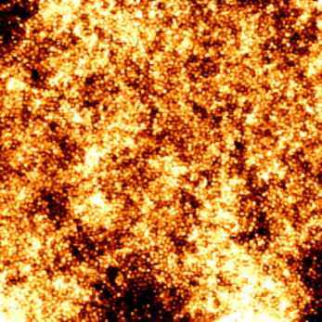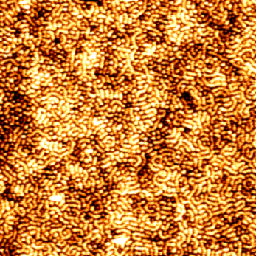
(a)
(b)
Fig.1: AFM topographic images (2x2μm) of PS-b-P4VP cylindrical microdomains (a) Perpendicular alignment of PS-b-P4VP cylinders on Si substrate after 30 minutes annealing in Toluene/THF atmosphere. (b) Flipping of morphology (parallel alignment of the cylinders) after 5 hours in same solvent annealing conditions.

References:
1. H. Kim, J. Hwang, W. S. Hwang, J. Huh, H.-C. Kim, S. H. Kim, J. M. Hong, E. L. Thomas, C. Park, Adv. Mater.,
2008, 20, 522-527
2. Dong Ok Shin, Duck Hyun Lee, Hyoung Seok-Moon, Seong-Jun Jeong, Ju Young Kim, Jeong Ho Mun,
Heesook Cho, Soojin Park, Sang Ouk Kim, Adv. Funct. Mater., 2011, 21, 250-254

Controlled Assembly of Iron-oxide Nanoparticles; Mechanism and Scale up.

Eoin Fox, Ninjbadgar Tsedev. and Dermot Brougham

School of Chemical Sciences, DCU, Glasnevin, Dublin 9.

dermot.brougham@dcu.ie

Superparamagnetic nanoparticles (NP) of iron oxide (IO) are under active consideration for a range of biomedical applications including magnetic resonance imaging¹, hyperthermia² and magnetically targeted delivery. One potential downfall is that the magnetisation of the nanoparticles is limited due to the small volume. The size of the nanoparticles cannot be increased sufficiently while retaining the superparamagnetic properties. We have developed a method whereby we can assemble nanoparticles into superparamagnetic clusters in a controlled manner^{3,4}. In this presentation we describe the mechanisms governing the assembly process and show that our approach can be used for large scale production.
Figure 1: DLS size distributions of 1.2ml scale and 15ml scale assembly process

References
- Bruns, O.T. et al., Nature Nanotech, 4, (2009), 193-201.
- Jordan. A., Journal of Magnetism and Magnetic Materials 201 (1999) 413-419
- C. J. Meledandri, J. K. Stolarczyk, D. F. Brougham, Hierarchical gold-decorated magnetic nanoparticle clusters with controlled size, ACS Nano, 2011, 5(3), 1747-1755. Patent: GB0922052.6 (17/12/09), PCT/EP2010/70121 (17/12/10).
- J. K. Stolarczyk, S. Ghosh, D. F. Brougham, Controlled growth of nanoparticle clusters through competitive stabilizer desorption ,Angewandte Chemie Int. Ed., 2009, 48(1), 175-178., Patent: GB0922052.6 (17/12/09), PCT/EP2010/70121 (17/12/10)

Organic Functionalisation of Semiconductor Nanowires

John J. O’Connell, Brenda O. Long, Justin D. Holmes, Gerard P. McGlacken¹
- Materials Chemistry and Analysis Group, Department of Chemistry and Tyndall National Institute, University College Cork, College Road, Cork, Ireland

john.oconnell@tyndall.ie

Major challenges currently exist with the scaling of electronic circuits to the nanoscale. One of the biggest challenges at this scale is the diminished ability to control the doping of semiconductor materials such as Ge and Si with atomic accuracy. Recently, Javey et al, have presented a novel method for controlled doping of materials using a technique called molecular layer doping (MLD).¹ MLD forms a uniform monolayer of dopant molecules which are covalently bonded to the semiconductor surface. This surface is then subjected to a rapid thermal annealing step which diffuses the dopants into the semiconductor lattice according to the required doping profile. To date, we have synthesised dopant precursor molecules and we have also grown germanium nanowires Fig. 1.. It is proposed to use these organic dopant molecules to functionalise the germanium nanowires and characterise their effects and evaluate their usage as part of next generation transistor technology as shown in Fig. 2.
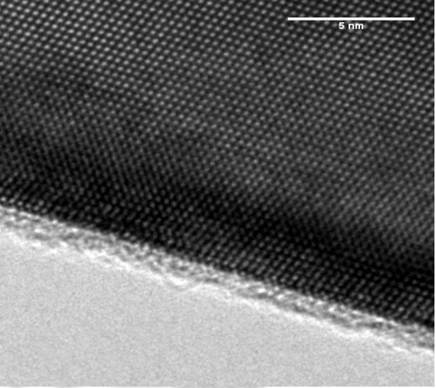
Ge nanowire
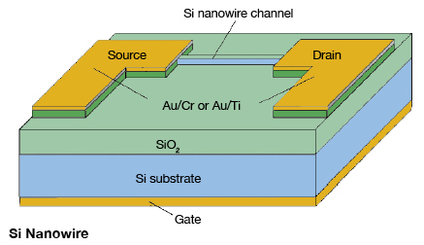

Figure 1: TEM image of a functionalised Ge nanowire Figure 2: Schematic diagram of a transistor

References
- Ho, J.C, Yerushalmi, R., Jacobsen, Z.A., Fan. Z, Alley, R.L., Javey, A., Nature. Mater , 2008, 7, 62-67.

Integrated methodology for characterization of nanoparticles bio-interactions in biological milieu

A. S. Pitek^{1,2}, M. P. Monopoli^{1,2}, E. Mahon¹, A. Salvati^{1,2}, F. Baldelli Bombelli³, I. Lynch¹ and K. A. Dawson¹

1. Centre for BioNano Interactions, School of Chemistry and Chemical Biology, University College Dublin,
Ireland;
2. Conway Institute for Biomolecular and Biomedical Research, University College Dublin, Ireland;
3. School of Pharmacy, University of East Anglia, Norwich, United Kingdom

Andrzej.Pitek@cbni.ucd.ie

The bio-medical sector is one of the most promising areas of nanotechnology, where nanoparticles (NPs) can potentially contribute to the development of new strategies to cure diseases. Specific design of NPs’ surface, and functionalization with protein epitopes specifically recognised by cellular receptors, has been a strategy broadly employed within the field to target NPs to specific destinations and/or to a particular kind of cell (and even to specific compartments) with limited success to date.
It is well established, that NPs in contact with bio-fluids are immediately coated with bio-molecules, which form a layer called the “protein corona”. In biological milieu cellular machinery rarely “see” the pristine/bulk material and its interaction with NPs is strictly dependant on the “corona” composition. A key objective in nanoscience, is to study interactions between NPs and those biomolecules that form the “corona” upon contact with a living organism (“first order interactions”), as well as the interactions of these NP-protein complexes with proteins expressed on cells surface (“second order interactions”).
To date, an integrated approach regarding characterization of NPs for biomedical use has been lacking. We demonstrate a characterization methodology where Protein-NP complexes are described both in situ (in biological medium) and after separation from excess proteins, in terms of dispersion properties, “corona” structural properties & proteomic composition, and second-order interactions with proteins expressed by cells. To achieve this, a novel characterisation method, based on differential centrifugation sedimentation is presented, which can be used to validate functionalised NPs for targeting in situ.
Considering the fact that many NP targeting strategies that are demonstrated successfully in simple buffers fail in the protein crowded environment found in vivo, our data highlights the importance of applying this characterisation methodology in advance of the application of engineered NPs in biological environments.

Magnetic Nanoparticles as a Tool to Harvest Cellular Organelles and Study the Nanoparticle Protein Corona in situ

F. Bertoli,¹ M. Monopoli¹, M. Moloney¹, A. Salvati1, K. A. Dawson¹

1. Centre For BioNano Interactions (CBNI), School of Chemistry and Chemical Biology University College Dublin Belfield, Dublin 4, Ireland,

Filippo.Bertoli@cbni.ucd.ie

Super paramagnetic iron oxide nanoparticles (SPIONs) have attracted a great deal of attention due to their properties which could see potential uses in biomedicine, magnetic resonance imaging, data storage and environmental remediation.
However, a full understanding of how the physical-chemical properties of nanomaterials (such as size, surface composition, etc.) affect their interaction with cells has yet to be reached; also, there is still limited knowledge on how the layer of proteins adsorbed on the nanoparticles’ surface (protein corona) affects the uptake mechanism, final intracellular location and eventual impact of the nanoparticle on cellular functions.
To fully comprehend these issues, it is fundamental to achieve a detailed mapping of the protein corona evolution inside the cell. In this context, the development of a method of isolation of the nanoparticles and of the organelles in which they are contained is a crucial step. The methods currently used in biology (mainly density gradients) could be affected by the presence of nanoparticles; also these techniques could not reach the level of purity required for this study.
Here the magnetic properties of SPIONs have been used to isolate first the organelles containing the nanoparticles, and then the nanoparticles alone. In this study the cellular uptake and localisation of three different SPIONs (50 nm and 150 silica coated magnetite and 50 nm dextran coated iron oxide) by A549 cells has been determined with electron and confocal microscopy. The results show these nanoparticles enter the cells and their final destination is accumulation in the lysosomes.
Moreover, time resolved extraction of the organelles containing the nanoparticles has been performed and the isolated organelles have been characterised by western blot, SDS PAGE, electron microscopy and mass spectrometry. Our results showed the presence of endocytic pathway markers on the recovered organellar fractions, confirming previous results regarding the uptake pathway.
Preliminary data on the nanoparticles harvested from the isolated organelles also indicate that the extracellular protein corona is retained as the nanoparticles accumulate in the lysosomes.

ULTRA-SENSITIVE DNA DETECTION BASED ON NANOPARTICLE FUNCTIONALIZATION AND ELECTROCATALYSIS OF NANOPARTICLE RELEASE

Hazel McArdle, Elaine Spain, Tia E. Keyes, Robert J. Forster¹
1. School of Chemical Sciences, Dublin City University, Dublin 9, Ireland.
Robert.Forster@DCU.ie Tel.: +353 1 7005943; Fax: +353 1 7005503.

Self assembled monolayers (SAMs) of dodecanethiol have been assembled on gold disc electrodes with nanoscale defects which act as nucleation sites for electrodepositing platinum nanoparticles (PtNPs). The PtNPs were deposited and grown in a hemispherical shape in the monolayer defects by the double-potential step method. A nucleation pulse with a large overpotential was used to achieve instantaneous nucleation on the gold surface; followed by a growth potential to grow PtNPs at the desired rate. These PtNPs were then functionalized with single stranded probe DNA. After DNA hybridisation, the PtNPs were desorbed from the gold electrode surface by applying a large current jump. A second electrode was functionalized with single stranded capture DNA and hybridized with complementary target DNA of varying concentrations. This DNA modified electrode was then placed into the desorbed PtNP / probe solution that have a sequence complementary to the target DNA associated with mastitis (Fig 1). Detection of the PtNP/probe hybridisation is monitored by the reduction of hydrogen peroxide to water and oxygen in H₂SO₄. Scanning electron microscopy (SEM) images were obtained at each step of the process, to show how the gold surface is modified by the PtNPs at a nanoscale resolution.
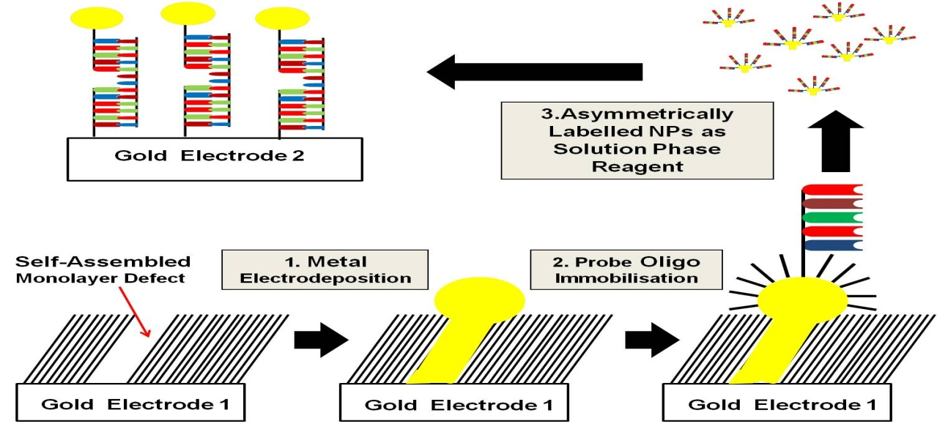
Figure 1. Platinum nanoparticle formation and DNA functionalisation

