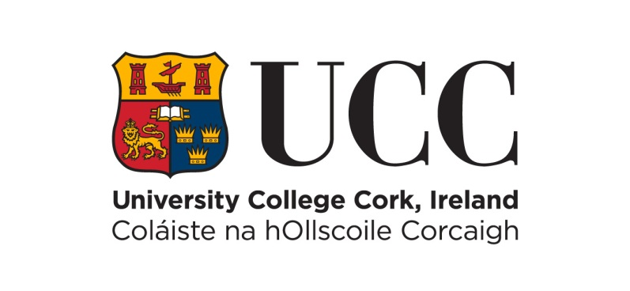

**LECTURER IN BIOINORGANIC CHEMISTRY**

**School of Chemistry, Future Pharmaceuticals**

**and the Analytical and Biological Chemistry Research Facility (ABCRF)**

**College of Science, Engineering & Food Science**

**Permanent Whole-Time Post**

UCC seeks to appoint a Lecturer in Bioinorganic Chemistry as part of UCC Futures, an ambitious programme of research prioritisation requiring experts from multiple disciplines and sectors to collaborate in new and reimagined ways. Applicants interested in applying for the position should have a PhD in Bioinorganic Chemistry, or closely related area, and demonstrate a proven commitment to leadership and excellence in research and teaching as evidenced by a scholarly reputation of international standing.

The successful applicant’s research activities will form an integral part of the Inorganic Section, cognizant of the increasing emphasis on growing academic and industrial collaborative research, both nationally and internationally. Research fields across all areas of Bioinorganic Chemistry will be considered, including emerging and/or interdisciplinary areas. Research fields that are aligned with UCC Futures - Future Pharmaceuticals research activities are particularly welcomed.

The post will involve teaching and project supervision across the diverse undergraduate degrees provided by the School, including BSc in Chemistry, Chemistry of Pharmaceutical Compounds, Chemistry with Forensic Science and Chemical Physics, and contributions to degrees led by other Schools, as well as future postgraduate programmes. The School holds an Athena SWAN Bronze Award and is proactively committed to equality and diversity in the workplace.

The Analytical & Biological Chemistry Research Facility (ABCRF) is a state-of-the-art interdisciplinary research centre housed in the Pharmacy Building, University College Cork. The ABCRF houses several state-of-the-art Bruker NMR spectrometers (including a 600 MHz instrument). Electrospray Ionisation mass spectrometers from Waters/Micromass are available in at the ABCRF, including an LCT Premier Time of Flight and a Quattro triple quadrupole instrument. Both instruments are configured for high throughput liquid chromatography mass spectrometry (LCMS). Bruker single-crystal XRD and Stoe powder XRD instrumentation is available.

The successful applicant will be supported in embedding and enhancing their research activities, with a particular focus on the acquisition of funding through the European Research Council programme.

Please note that Garda vetting and/or an international police clearance check may form part of the selection process.

For an information package including full details of the post, selection criteria and application process see <https://ore.ucc.ie/>. The University, at its discretion, may undertake to make an additional appointment(s) from this competition following the conclusion of the process.

Informal enquiries can be made in confidence to: Dr Simon Lawrence, Head of Inorganic Chemistry, Email: [simon.lawrence@ucc.ie](mailto:simon.lawrence@ucc.ie) , or Professor Anita Maguire, Head of School, Email: [a.maguire@ucc.ie](mailto:a.maguire@ucc.ie)

For further information on the School of Chemistry please visit <https://www.ucc.ie/en/chemistry/>. For more information on the ABCRF visit <https://www.ucc.ie/en/abcrf/>

University College Cork is committed to being a fully inclusive global university which actively recruits, supports and retains colleagues from all sectors of society. Equality, Diversity and Inclusion (EDI) are core values under our [UCC Strategic Plan 2023-2028](https://eur01.safelinks.protection.outlook.com/?url=https%3A%2F%2Fwww.ucc.ie%2Fen%2Fpresident%2Fstrategy2028%2F&data=05%7C02%7Cjessica.murphy%40ucc.ie%7C93fb0a497dc04206467708dce9d9db98%7C46fe5ca5866f4e4292e9ed8786245545%7C0%7C0%7C638642369157578136%7CUnknown%7CTWFpbGZsb3d8eyJWIjoiMC4wLjAwMDAiLCJQIjoiV2luMzIiLCJBTiI6Ik1haWwiLCJXVCI6Mn0%3D%7C0%7C%7C%7C&sdata=a0D5sx%2FRmrje%2BreN0jpJQHRqlBmmx4JmHclo%2FTzwJPo%3D&reserved=0). UCC holds a [Bronze Athena SWAN](https://www.advance-he.ac.uk/equality-charters/international-charters/athena-swan-ireland) award  in recognition of our commitment to advancing equality in higher education. We value diversity as well as celebrate, support and thrive on the contributions of all our employees and the communities they represent.  We are proud to be an equal opportunities employer and encourage applications from everybody, regardless of age, care-giving status, disability, ethnicity, gender and/or gender identity or expression status, nationality, marital status/civil partnership, pregnancy and maternity, race, religion/creed, and/or sexual orientation. We are committed to supporting all staff through flexible working schemes, family-friendly policies, training and development, and staff networks. We value the enrichment that comes from a diverse community and seek to promote equality, prevent discrimination and protect the human rights of each individual in line with equality legislation. We encourage applicants to consult our [Dignity and Respect Policy](https://www.ucc.ie/en/media/support/hr/DRRD-1Dec2020(final).pdf) and learn more about our [EDI related initiatives](https://www.ucc.ie/en/edi/) .

Appointment may be made on the Lecturer Above the Bar Salary Scale: €76,863 - €99,543 (Scale B) / €73,130 - €94,564 (Scale A).

***Salary placement on appointment will be in accordance with public sector pay policy.***

We encourage you to reach out to us directly should you require assistance or reasonable accommodation during the recruitment process.

**Please note that interviews will take place online via MS Teams.**

Applications must be submitted online via the University College Cork vacancy portal (<https://ore.ucc.ie/>). Queries relating to the online application process should be referred to [recruitment@ucc.ie](mailto:recruitment@ucc.ie), quoting the job-title.

Candidates should apply, in confidence, **before 12 noon (Irish Local Time) on Tuesday, 11th February 2025.**

**No late applications will be accepted.**

**UNIVERSITY COLLEGE CORK IS AN EQUAL OPPORTUNITIES EMPLOYER**

**Please note that an appointment to posts advertised will be dependent on University approval, together with the terms of the employment control framework for the higher education sector**